Les along with the
Official international publication
OF THE ASSOCIATED LOCKSMITHS
OF AMERICA, INC.
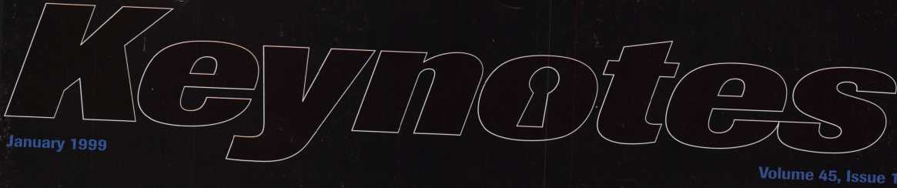
IN THIS ISSUE
THE VERY BEST OF
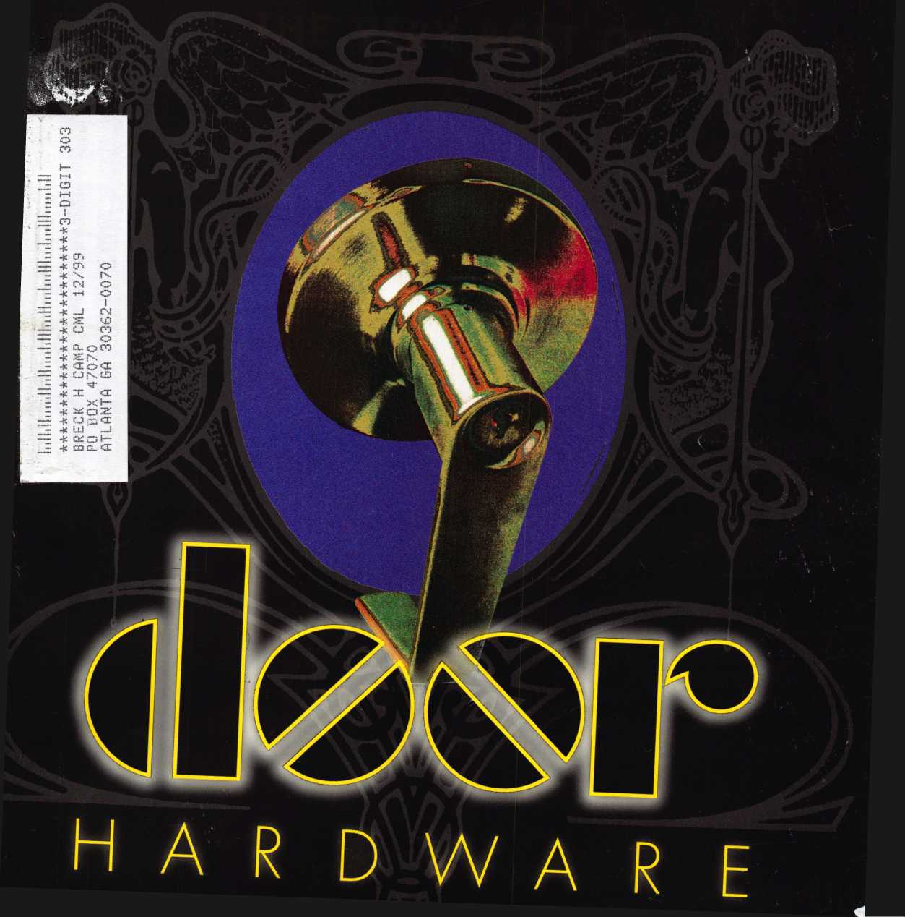

Feel

Luckv?_
f
You wouldn’t dream of leaving your success
to chance. You know that making it in the safe
and vault industry requires hard work, continual
improvement of techniques, and constant research
of the latest products and tools.
Your best bet to excel in all these areas is
SAFETECH ’99 where you can save your luck for
the casinos, and get d.own to business viewing
the latest products, talking with the manufacturers,
and training in the latest methods of
safe and vault technology.
Make your plans now to attend
SAFETECH ’99 May 3-8, 1999
in Las Vegas, NV.
LAS VEGAS, IMV « MAY 3-B
Contact:
Safe and Vault Technicians Association
3003 Live Oak Street Dallas, TX 75204 214.827.7233 214.827.1810 fax email: convtion@anet-dfw.com

Spotting a fresh face
could get you some great stuff.
Facing Facts
Do you know what happens when you sponsor an individual for membership in your national association? You strengthen the voice of the industry and you help another locksmith along the road to complete professionalism.
As an added bonus, for each member you sponsor during 1999, you will receive $40 in Convention Bucks (good for ALOA registration, classes, goods and services at ALOA '99 or ALOA 2000),
and an entry in a drawing for one of several incredible prizes, some valued up to $2,199!! You could be the winner of a: Rytan RY100 Duplicating Machine, HPC1200 Blitz Code Machine, Silca Bravo USA Duplicating Machine, Framon Sidewinder Duplicating
Machine, JET ETD-1 Transponder Key Decoder Kit, Silca RW2 Transponder REader/Duplicator, High Tech Tools Pro Lockout Kit or a DeWalt 18V 1/2" Cordless Hammerdrill and Reciprocating Saw Set!
Keep An Eye Out
Everybody wins when you spot that next ALOA member. Let's put our noses to the grindstone and enter the next century with a larger, stronger membership. You can get a copy of ALOA's membership application on our web page at www.aloa.org under "Joining ALOA,"or by calling 1.800.532.2562. Sign up a friend today, and send us their photo so that we can include them in future ads!

ontenrs
Features
lannary
99
Volume 45, Issue 1
The Cover:
Weird scenes inside the “door mine”... we focus on door hardware with news on “golden oldie” renovations, and the new “pop” products that have everyone singing their praises.
President’s Journey
By Dallas Brooks
16
Titan Commercial Series Lever Handle Lock
Learn the ins and outs of this new piece of door hardware.
By Sal Dulcamara, CML
19
Legislative Comment
Our legislative expert provides an update on
ALOA’s strengthened relationship with the government
By Tim McMullen
20
Hardware Restoration
Stop! Don’t get down and dirty with that restoration
project until you get some vital tips that could
save you time and money!
By Don Dennis, CPL
22
Schlage AL-Series Lever
The folks at Schlage offer a new variation on
a classic hardware concept.
By Sal Dulcamara, CML
Best Type Interchangeable Cores, Part II
Part II in an insightful look into the tricks of working with Best Interchangeable Cores.
By Charles H. Cole, CML
28
Mississppi Learning
An ACE class provides an afternoon of education and charity in ole Miss.
By Paul F. Chandler, CRL
30
Abus Diskus-Now Rekeyable
A padlock is just a padlock, right?
Get the facts from our Abus authority.
By Sal Dulcamara, CML
33
The PRP. Oh, How You’ve Changed!
Dylan wrote “the times, they are a changin’.” Our author
applies such wisdom to the ever evolving state of the PRP.
By Claire Cohen, CML
34
Art direction/design The Shop Van
Valerie Rowe Image is everything, especially when it concerns
your company vehicle. Get some inside tips from
a man who knows his vans.
By Michael Ferrill
Departments
Upcoming Events
8
Security Marketplace
e*
10
Applicants for membership
Scheduled for clearance Feb. 1
11
Authors in This Issue
12
Core
Board Nominations due April 1; and
Keynotes pays its respects to an
industry legend, Stan Fuher
44
Back Page
2 | Keynotes
January 1999
ilia
:
36
Associate Members
42
Ad Index
40
Classifieds

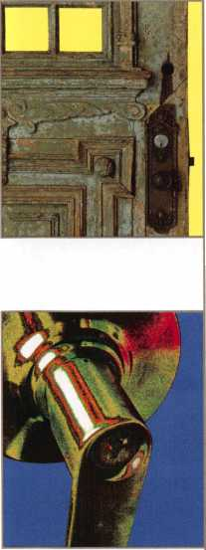
Editor | Anne McDonald Davis, ABC keynotes@anet-dfw.com
Managing Editor | Mike Emery keynotes@anet-dfw.com
Technical Editor | David Lowell, CML, CMS david@aloa.ioffice.com
Editorial Advisor | John D. Cannon, CML jdcannon@worldnet.att.net
Advertising Sales | Marvin Diamond  Lionhart Publishing (770) 431-0867, ext. 208 anelia@aloa.ioffice.com
Contributing Authors | Jerome V. Andrews, CML Paul Chandler, CRL  Claire Cohen, CML  Brian Costley, CML, CMS Bob De Weese, CPL  Ray D’Adamo, CML  Sal Dulcamara, CML  James Glazier, CML  Daniel Graffeo, CRL, CMS Wayne Gurnee, CRL  A.J. Hoffman, CML  Ken Holmlund, CRL  Ray Lusk, CML  Mark Ohno  Randy Simpson, CML  Robert Stafford, CPL  Dave Thielen
ALOA Professional Staff
Executive Director | Charles W. Gibson, Jr., CAE charlie@aloa.ioffice.com
Operations Manager | Mary May  mary@aloa.ioffice.com
Receptionist | Shenika Theus
Comptroller | Kathy J. Romo
Finance Coordinator | Janelle Vergara
Meetings Manager | Jessica Vasquez jessica@aloa.ioffice.com
Meetings Coordinator | Janelle Vergara
Government Affairs Manager | Tim McMullen tim@aloa.ioffice.com
PRP/Education Manager | David Lowell, CML, CMS david@aloa.ioffice.com
Education Assistant | Ashley Spencer
Membership Coordinator | Brandon Durrett brandon@aloa.ioffice.com
Membership Assistant | Jackie Arnett
Chapters & Regional
Associations Liaison | Tim McMullen tim@aloa.ioffice.com

Executive
Additional contact information for the ALOA Board and most Keynotes authors are available through “Locksmith Search” on the ALOA website- www.aioa.org or by contacting the ALOA office at 3003 Live Oak Street; Dallas, TX 75204; (800)532-2562; FAX (214) 827-1810; e-mail aloa@aloa.org.
Mission Statement: The Associated Locksmiths of America, Inc. is dedicated to enhancing the professionalism, education and ethics among locksmiths and those in related sectors of the physical security industry. With approximately 10,000 members in the United States, Canada and the freeworld, ALOA is poised to help members obtain the knowledge, the strength, and the confidence to perform their role in the physical security field with pride and dignity. But it is only through active involvement and participation that ALOA can fully achieve its potential-and can help members to achieve theirs.
Policies: Keynoted is the official publication of the Associated Locksmiths of America, Inc. [ALOA). Keynoted acts as a moderator without approving, disapproving, or guaranteeing the validity or accuracy of any data, claim, or opinion appearing under a byline or obtained or quoted from an acknowledged source. The opinions expressed by the authors do not necessarily reflect the official views of ALOA. Also, appearance of advertisements and new products or service information does not constitute an endorsement of products or services featured by the Association. The Association does not accept responsibility for the inaccuracy of any data, claim, or opinion appearing in this publication, due to typographical errors on the part of the authors, Association staff or its agents. Editor’s Note: This publication is designed to provide accurate and authoritative information in regard to the subject matter covered. It is provided and disseminated with the understanding that the publisher is not engaged in rendering legal or other professional services. If legal advice and other expert assistance is required, the services of a competent professional should be sought.
Authors’ Payment: Payment for eligible submissions to Keynotes will be based on the following criteria: topic, time spent and past contributions. Authors who regularly submit to Keynotes are generally paid a higher rate. The latter is especially true of authors who write to fit specific editorial needs and submit said copy by Keynotes deadlines. As a general guideline: Average payment for a 750 word, business or ‘light’ technical article would be $200. Payment for a 1500 word article involving significantly higher time and research efforts would be $400.
Payment will not be offered for articles submitted by ALOA employees or members of the ALOA Board of Directors [unless material is of a technical nature), nor for articles submitted by a company that promote that company’s products or services. ALOA reserves the right not to pay for articles submitted by an individuals) that promote a particular company’s products or services.
Disclaimer: The Associated Locksmiths of America, Inc., [ALOA), reserves the right to refuse any article for any reason. Additionally, ALOA reserves the right to edit, amend or modify any article submitted for publication in order to preserve technical accuracy, clarity, fairness or grammatical correctness. ALOA will make the best efforts to notify the author of any changes. The extent of ALOA’s liability for any article or information contained therein will be a notice of correction or retraction in the next possible issue.
Keynotes® [ISSN 0277 0792) is published monthly except for the combined June/July issue by The Associated Locksmiths of America, Inc., 3003 Live Oak St., Dallas, TX 75204-6186. Telephone: (214) 827-1701; FAX (214) 827-1810; e-mail aloa@aloa.org. Subscription rates for members-$15.00 per year. Second class postage paid at Dallas, Texas. POSTMASTER: Send address changes to: Keynotes, 3003 Live Oak St., Dallas, TX 75204-6186. © Copyright 1999, All rights reserved. No part of the contents may be reproduced or reprinted in any form without prior written permission of the publisher.
Board
President
Dallas C. Brooks (334) 826-8990
Secretary
John D. Cannon, CML (703) 960-6413
Directors, Northeast
James H. Glazier, CML (301) 831-5454 John G. Magee, III
- 845-3434 William L. Young, CML
- ) 647-5042
Directors, Southeast
Jeffreys. Nunberg, CML, CMS (305) 324-8800 Donald R. Rule, CML (601) 324-2658
Directors, North Central
Mark E. Blum. CML, CPS (517) 482-5809 John J. Greenan (773) 486-2030
Director, South Central
Randy L. Simpson, CML (713) 780-7026
Directors, Southwest
Gordon Racine, CML (719) 384-4707 John I. Shandy, CML (303) 774-9791
Director, Northwest
Scott Henke, CRL, CPS (907) 248-3785
Director, Associate Members
Judd Penske (800) 634-5465
Non-voting directors
Jerome V. Andrews, CML (216) 252-9586 Steve G. Engel, CML, CPP (920) 731-5400
Trustees
David M. Lowell,CML, CMS (800) 532-2562 Breck H. Camp, CML (770) 455-6244 Henry H. Printz, CML (973) 538-2737 Leonard J. Passarello, CPL (416) 752-7210 Edwin Toepfer, RL (416) 225-5589
Chairmen of International Affairs
Laurence P. Mills/Australia (129) 958-0445 Hans Mejlshede, CMLVEurope FAX (453) 139-1004
Past Presidents
1995-1997 David Lowell, CML, CMS 1993-1995 Breck Camp, CML 1991-1993 Henry Printz, CML 1989-1991 Evelyn Wersonick, CML, CPS 1987-1989 Leonard Passarello, CPL 1985-1987 Joe Jackman, CML 1983-1985 Stanley Haney, CPL 1981-1983 Louis LaGreco, CPL 1979-1981 John Kerr, RL 1977-1979 Clifford Cox, CML 1974-1977 Charles Hetherington 1972-1974 Gene Laughridge 1970-1972 William Dutcher, RL 1968-1970 Constant Maffrey, RL 1966-1968 Harold Edelstein, RL 1964-1966 William Meacham 1962-1964 Robert Rackliffe, CPL 1960-1962 Edwin Toepfer, RL 1956-1960 Ernest Johannesen
Keynotes \ 3
January 1999

I
Happy New Year to all! I hope everyone enjoyed the holidays. Another year
has come and gone, and we are all one year older and a lot wiser, right?
I am very excited about the New Year for ALOA. We now have five new
members seated on your ALOA Board of Directors that were elected under
the new ALOA Bylaws. None of these five had ever served on the board
previously. They have just attended their first board meeting in Dallas, Texas,
December 10-13 and I can tell you that they did a great job contributing to the
decision making process of governing your association. The entire board worked
very hard last week debating issues, making decisions and planning for the New
Year. I can assure you this board will work hard to make ALOA the best that it
can be. I hope you will assist the board in doing this by attending your local
chapter or associations meetings and inviting your board’s representative to
attend. Take this opportunity to share your ideas and feelings with him. If for
some reason, he can not attend your meeting in person, request that he attend by
the use of a speakerphone. At the very least, I hope you will communicate with
your board member by mail, email or phone.
One decision made by the board concerned membership numbers. In the
past, if a member let his membership expire for whatever reason, he could only
rejoin and keep his old number if he paid all back dues from the time of his
membership expiration. This is still an option. A member who chooses to pay all
back dues will receive his or her old number and be credited with continuous
membership. A new option has been added. A member may pay his current dues
and an administrative fee (the amount to be determined) and retain his old
number. However, the “member since” will be changed to the date of the
renewal. An example of the difference is the membership card. The card has the
“member since” date printed on it. This date will be the original date for those
who pay all back dues but will be the date of renewal for those who choose to
keep the old number without paying the back dues.
This will accomplish two things. It addresses the desire of some who would
like to rejoin ALOA and get their old number back, as well as simplifying the
record keeping duties of our Education and PRP departments. Now, I want to
say again that this new option will not enable someone to drop out of ALOA and
later rejoin and have recognition of continuous service to ALOA. If you know
anyone who used to be an ALOA member, please give them a call and urge then
to rejoin and tell them it is possible to get their old number back. I would like
to challenge all of you to make a commitment to get and sponsor one new
member in 1999-
I am sure all of you know a locksmith in your area that is currently not an ALOA member. Please take time to encourage them to join. Locksmiths working together within an association such as ALOA can benefit everyone in our industry.
Once again, I would like to wish everyone a happy and prosperous New Year!

Dallas C. Brooks President
4 I Keynotes
January 1999

Kwok-kei Leung
Henry Raymond
Toshihiro Asano
Stewart Levine, CML
Mary Ohmit, CPL
Charles Robertson, CML.
Yuriko Yanai
Jack Hobin, CPL
Allen Konrath
Salvatore Dulcamaro, CML.
Myeong-Rae Cho
William Neff, CML
David Lowell, CML -
Thomas Freehling, CML —
Dana Barnum, CML
Jeanne Lodge, CML
John Heckman, CML
Barry Leas, CRL
J. Thomas Hood, CML
Roy Renderer, CML
Danny Rudd, CPL
John Elliott, CML
Larry Warnick, CML
James Watt, CML
Robert Carroll, CPL
__169
93
81
67
64
63
61
51
49
39
38
35
32
32
31
31
29
28
26
25
24
24
24
23
23

The Brightest

And The Best.
Diana Barnum, CRL | 22
Barbara Watt | 22
David M A Federico | 22
Robert DeWeese, CPL | 22
Jim Williams | 22
Anthony Ramunno, CML | 21
Jerome Cohen, CML | 21
Eugene Altobella | 21
Lawrence F. Smith, Jr. CML | 21
Charlp*; Cole CML | 19 | Frank Hartung, CML | 13
Llldllcb cuic, ci il.  Marian ^wann CRL | 18 | Robert Duman, CML | 13
rldildll JWCUMif ci\l-  n Mirhapl 1 PP CPL | 18 | Jon Griswold, CML | 13
U• rllclldcl LCC^ cr l.  lamoc Fnwlpr CMI | 18 | Paul Souber | 13
Jdlllcb ruwici/ ci il  Rax/iH Harris CMI | 18 | Daniel Landry | 13
UdVIU ndi i lb, crii_  Elvis Hammerschmidt, CPL | 18 | Robert Rodocker, CRL | 12
"Inhn Kprr RL | 17 | Keiryu Tsukishiro | 12
UUIIII IXCII, IM- ■—  Inhn nnrCPV/ CPI | 17 | Rolando Bouza | 12
JUIIII lmji bey, cr  Rnnalrl HpiHzid | 17 | Lonnie McKinney, CML | 12
ixUildlu nciuz.iy  "lncpnh Fprrprn CML | 16 | James Brickler, CRL | 12
jubeun i ci iciu, ci il.  lamoc Ca\A/h\/ CMI | 16 | Richard Sievers | 12
Jdlllcb Ldwuy, ci il. .—  William Crant CRL | 16 | Joe Lee, CRL | 12
YV1 111 dill vjldiiL, ci\l.  Dhiiin Pm/onnlt CPI | 16 | Eric Veal | 12
rniup ixUVciiuil, cr l  Mirhaol RnhirKnn fRl | 16 | Steven Spiwak, CRL | 12
rllCridcl i\UU 11 ibU11, ci\c  Rrian Reetz | 16 | Herbert Dusenberry, CML | 11
Ullaii ixttu  Waltpr 1 a<;rar RL | 15 | Raymond Lusk, CML | 11
VVolLCi Laocai, ixi—  Thrkrrvac \/a nHorc1"PPn CMI | 15 | Robin Horsley | 11
1 nOmaS VdllUcIblCCl 1, criL  riarx/ Tpam<; CPL | 15 | John Engel, CRL | 11
udiy lediiib, cil  VA/illi-am MrFl hpnp\/ CMI | 15 | Donald Shiles | 11
William ImLCLIIci Icy, ui’ii-  Day Parmplpp Rl | 14 | Thomas Demont, CML | 10
I\ca rdiiiieicc, i\c  lamoc Crnhpr CRI | 14 | Ernest Wright | 10
JdiTicb \JIUUCI, CI\L  |/pi7n T^kdhdshi | 14 | William Wickward, CML | 10
Ruccoll Fullpr CRL | 14 | Lester Brodsky | 10
Klibbcll ruiiei, cr\c  1 FHwin W Srott | 13 | Joseph Whitaker, CPL | 10
1CUWIII VY JLUll  Peter Gauthier, CPL | 13 | Dale Knowles, CPL | 10
How can I join the President's Club?
You can earn membership in this prestigious club by
recruiting just 10 new members for ALOA.
*Any ALOA member may participate.
What do I get?
When you recruit 10 members, you receive a handsome
blue blazer with a President's Club crest. For each
additional five members you recruit, you receive a
lapel pin with gold-filled numbers, indicating your
recruiting successes.
You also get the satisfaction of knowing that you are
helping your association, helping your industry grow,
and you are helping fellow locksmiths achieve success.
How do I get started?
Contact the ALOA office for a supply of applications
(214) 827-1701 or FAX (214) 827-1810. One President's
Club credit is awarded for each new applicant. Credit is
awarded only after the membership application is
approved. However, the credit will apply for the period
in which the application is received. Failure to identify
yourself as the sponsor on the application form at the
time it is submitted to ALOA for processing will forfeit
any credit.
*ALOA Board of Directors not eligible for membership in the President's Club.
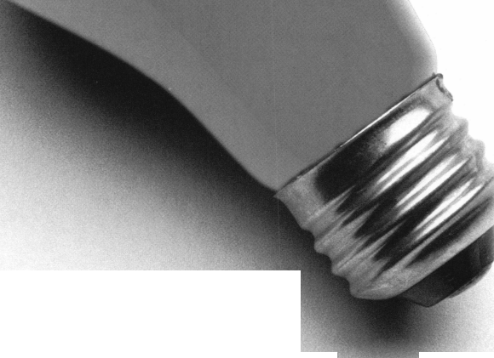

Upcoming

Events
fep, Indicates ALOA ACE Class
Indicates PRP Sitting
1999
JANUARY
9
t ALOA PRP SITTING
Locksmith Security Association
Detroit, Mich.
Contact: Sal Dulcamaro, CML
(810) 791-5416
(810) 792-4021 fax
9
CTv ACE Classes
Motorcycle Locksmithing
Wyoming Chapter
Casper, Wyo.
Contact: Gene Fieck, CPL
(605) 642-4542
(605) 642-8946 fax
16-17
MBA Training
Combination Lock Technology I
Nicholasville, Ky.
(888) 622-5495
17
/ ALOA PRP Sitting
Virginia Locksmith Association
Richmond, Va.
Contact: R. Terry Earll, CML
(703) 368-0595
(703) 335-0852 fax
20-21
MBA Training
Combination Lock Technology II
Nicholasville, Ky.
(888) 622-5495
25-29
Lockmasters Class
Fundamentals of Electricity
Nicholasville, Ky
(800) 654-0637, ext. 200
28-29
COMSEC ’99
Washington DC
(703) 519-6200
www.asisonline.org/comsec.html
FEBRUARY
1-5
Lockmasters Class
Electronic Access Control
Nicholasville, Ky.
(800) 654-0637, ext. 200
6-7
West Coast Lock Collectors Show
Arcadia, Calif.
Contact: Bob Heilemann
1427 Lincoln Blvd.
Santa Monica, Calif. 90401
(310) 230-3004 evenings or
(310) 454-7295 message
I
61 Keynotes
9-14
Texas Locksmiths Assoc. Annual Convention and Trade Show Contact: Jim Hetchler (registration) (830) 606-1727 or Pat Titus (booth space)
(210) 649-2166
14
f/ ALOA PRP SITTING Texas Locksmiths Association San Antonio, Texas Contact: Wanda Robbins (210) 923-4381 (210) 977-8398 fax
20-21
feu ACE Class Fundamentals of Masterkeying Grand Canyon Chapter of ALOA Phoenix, Ariz.
Contact: John Ilk, CRL (602) 921-0123 (602) 921-0524
21
f ALOA PRP Sitting Rocky Mountain Locksmiths Assoc. Airora, Colo.
Contact: John S. Todd, CRL (303) 730-8525 (303) 795-5114
22-23
Lockmasters Class Advanced Lock Picking Nicholasville, Ky (800) 654-0637, ext. 200
27-28
Lockmasters Class Simplex Certification Nicholasville, Ky (800) 654-0637, ext. 200
28
ff ALOA PRP SITTING Western Michigan Locksmiths Association, Kalamazoo, Mich. Contact: Terry L. Bussema, CRL (616) 381-5634 (616) 381-5654 fax
28
feL \ ACE Classes Studying for and Passing the PRP Western Mich. Locksmith Assoc. Kalamazoo, Mich.
Contact: Terry L. Bussema, CRL (606) 381-5634 (606) 381-5654 fax
28
Local Organizations for Continuing Education- South Florida Locksmiths Assoc./ Florida Latin Locksmiths Contact: Jerri (days)
(305) 944-0469;
or Wayne (evenings)
(305) 252-8355
MARCH
9-12
ISC Expo/Las Vegas ’99 Las Vegas, Nev.
Contact:
(203)840-5602
http://isc.reedexpo.com
12-14
IDN Hardware Sales, Inc. Security Conference Cleveland, Ohio Contact: Fred Strasberger,
John Kress or Bonnie Weston (800) 521-0955
18-21
ACE Classes Sponsor:
MLANJ Annual Convention Somerset, NJ (973) 267-8884 (973) 538-2248 fax www.mlanj.org
20
fjfr ALOA PRP Sitting
MLANJ
Somerset, NJ
Contact: Bill Timmann, CML (973) 267-8884 (973) 538-2248 fax
20-21
MBA Training Manipulation Nicholasville, Ky.
(888) 622-5495
21
Southern Lock Buyers Trade Show St. Petersburg, Fla.
Contact:
(800) 282-2837
28
ft ALOA PRP Sitting Rosemont, 111.
Clark Security Products Contact: Terri Burges (619) 974-5273 (619) 974-5284 fax
APRIL
n
^ ALOA PRP SITTING Montana Chapter of ALOA Butte, Mont.
Cooney’s Locksmith Contact: Walter P. Cooney, CML (406) 782-0125 (406) 782-0125 fax
11
ALOA PRP Sitting Oakland, Calif.
Clark Security Products Contact: Terri Burges (619) 974-5273 (619) 974-5284 fax
12-16
MBA Training
DoD Combination Locks
Nicholasville, Ky.
(888) 622-5495
17-18
MBA Training Professional Safe Drilling Nicholasville, Ky.
(888) 622-5495
MAY
4-9
SAFETECH ’99 Las Vegas, Nev.
(214)827-7233
JULY
25-31
ALOA ’99 Security Expo Cincinnati, Ohio (800) 532-2562
AUGUST
22
f/ ALOA PRP Sitting Baltimore, Md.
Clark Security Products Contact: Terri Burges (619) 974-5273 (619) 974-5284 fax
27-30
MLA’s London Convention Contact: Dave Stokes 139 Wood Street Walthamstow, London, E17 3LX 01144 181 520 7450
OCTOBER
10
ALOA PRP Sitting Burbank. Calif.
Clark Security Products Contact: Terri Burges (619) 974-5273 (619) 974-5284 fax
17
fi* ALOA PRP Sitting Penn/Ohio Locksmith Assoc. Coraopolis, Pa.
Contact: Martha R. Eggler (216) 676-8464 (216) 267-2511 fax
2000
APRIL
6-9
MLANJ 2000 Annual Convention Somerset, NJ (973) 267-8884 (973) 538-2248 fax www.mlanj.org
MAY
5-10
SAFETECH 2000 Birmingham, Ala.
(214) 827-7233
JULY
17-22
ALOA 2000 Las Vegas, Nev.
(214) 827-1701
2001
MARCH
28-April 1
MLANJ 2001 Annual Convention Somerset, NJ (973) 267-8884 (973) 538-2248 fax www.mlanj.org
JULY
15-21
ALOA 2001 Security Expo Baltimore, Md.
(800) 532-2562
2002
JULY
21-27
ALOA 2002 Security Expo Rosemont, 111.
(800) 532-2562
January 1999

'Timelocks... the professional's choice when only the best will do!"
Diebold 127R and Mosler 126R
Replacement Movements
FEATURES
/ Custom designed to retrofit most Diebold and
Mosler timelock cases
/13 jewel Swiss movements
/Heavy duty gear train
/Beautifully finished plates with cap-
tive mounting screws
/Yale, Kumahira and LeFebure
versions available
Regular Price: $225
Sale Price: $199.95
Sale Ends March 31,1999
127 SE 29th Street ♦ Topeka KS 66605 ♦ 888 798 8464 / Fax 800 798 TIME (8463) ♦ 785 232 8705 / Fax 785 232 2603

Need information in a hurry?
Just call 310.575.5074 and you will be faxed:
#1 A list of all documents available through this service
#2 Becoming A Locksmith
#3 Locksmith Career Summary
#4 Locksmith School List
#5 ACE Class Schedule
#6 Certification Information
#7 PRP Category List
#8 ALOA Membership Application
#9 ALOA List of Benefits
#10 Scholarship Application Form
#11 ALOA Video Library Order Form
#12 ALOA Membership Items Order Form
#13 Safe & Vault Technicians Association
Member Application/Subscription Form
#14 ALOA Chapter Roster
#15 Legislative Action Network
#16 Legislative Action Network Newsletters
#17 Various State Laws
#18 Industry Position Paper
Your association continues to explore ways to provide you, our members, with new benefits and services.
ALOA
HAS
FAX ON
DEMAND!
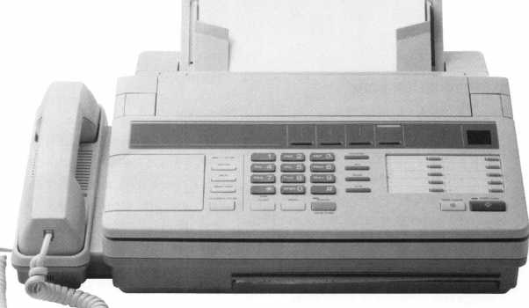

January 1999
Keynotes | 7
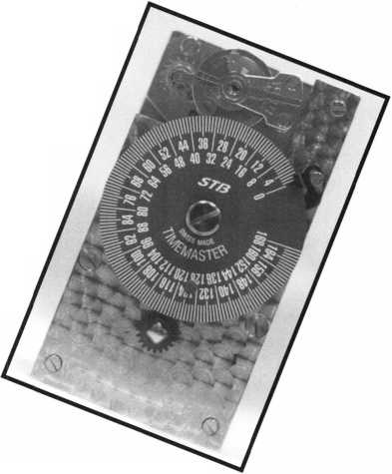
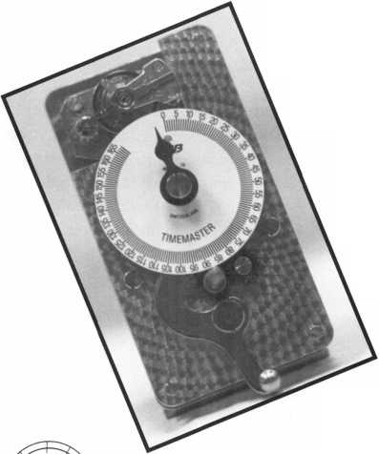

Security

Marketplace
Hitachi Power Tools
Hitachi Power Tools and National Nail Corp. have announced the introduction of the industry’s first collated cap nail fastening system. The Plasti-Tacker Pro system enables the contractor to affix house wrap, roofing felt and insulation sheathing. The system features a pneumatic nailer manufactured by Hitachi and National Nail’s plastic top fasteners and patented cap feeder.
Hitachi Power Tools 3950 Steve Reynolds Blvd.
Norcross, GA 30093 (770) 925-1774 (770) 923-2117 fax
DeWalt
DeWalt High Performance Tools and Accessories announces the expansion of its Series 40 Woodworking and Series 60 premium woodworking saw blade lines. The expansion, which brings the total number of Series 40 and Series 60 blades up to 53, includes 25 new table saw blades. DeWalt’s woodworking saw blade line has expanded to include blades for ripping and crosscutting various materials, including melamine, veneers, laminates and solid surface materials. These blades are now combined with a full range of blades for crosscutting with miter and slide miter saws. DeWalt Industrial Co.
PO Box 158 626 Hampstead Pike HampsteadMD 21074 (800) 4-DEWALT tvww.dewalt.com
Trans-Atlantic Company
Trans-Atlantic Company has a nine-inch universal locking laminated square slide bolt. It includes a laminated steel welded bolt with a one-and-a-half inch slide projections. It’s furnished with two strikes for either surface or mortise installation, and has a welded steel base and strap with a durable epoxy silver finish.
Trans-Atlantic Company 440 Fairmount Avenue Philadelphia, Pa. 19123 (800) 523-9956 (800) 531-0844fax
8 | Keynotes January 1999
Detex Corporation
Available from Detex is the F90KR heavy duty, keyed removable mullion designed for use on standard and fire-rated pairs of doors. It is made from 11 gauge 2"x 3" steel for strength and durability, is UL and Warnlock Hersey listed for three hour fire rated pairs of doors up to 8' x 8' and can be operated by a standard rim cylinder. The mullion is available in eight inch lengths and is can be field cut to a desired length. The F90KR is WHI Listed for use with other manufacturers’ fire exit hardware and comes with a one-year warranty.
Detex Corporation 302 Detex Drive New Braunfels, TX 78130 (800) 729-3839 (830)620-6711 fax
CCTV Corp./GBC
GBC recently introduced the GBC Mini-Max 700 Series. These miniature black and white cameras feature electronics and different lenses. Available are the CCD-700 with 4 mm lens (optional 2.5 mm, 6 mm,
8 mm and 12 mm), the CCD-700 PH with 3.6 pinhole lens (optional 5.5 mm pinhole lens) or the CCD-700CS that accommodates a “C”/”CS” lens. Models measure 1 1/2" high and wide and are ideal for applications where an inconspicuous camera is desired. All cameras come with an attachment bracket for adjustability on walls or ceilings.
CCTV Corp./GBC
280 Huyler Street
South Hackensack, NJ 07606
(800) 221-2240
(201) 489-01111 fax
Barantec
Available from Barantec is the Everswitch family of patented piezo products. Units are integrated with flash EEPROM based products and are marketed under the entry/SEN- TRY name. All units are weather proof, vandal proof and tamper proof. One model is a 2x6-mullion mount with integrated electronics. This single door controller has the keypad and electronics integrated into one unit. Barantec Plaza 777 Passaic Ave.
Fourth Floor Clifton, NJ 07012
Intromark, Inc.
Intromark, Inc. offers Strongbow, the Door Security System. This is designed for use on houses, apartments or buildings. Strongbow consists of a pair of square-section steel tubes (one slidably spring-mounted within the other) that terminate in a tough rubber foot-section at the floor end. Secured to the door, the assembly extends at a specific angle to the floor, ensuring a door reinforced with strongbow is like trying to drive a steel bar into the floor.
Strongbow can be used in external and outdoor applications is designed for installation by the user. It works with any type of door and with hard (wood, tile) and soft (carpet, linoleum) floor surfaces.
Intromark, Inc.
217 Ninth St.
Pittsburgh, PA 15222-3506
ATX Technologies, Inc.
ATX Technologies, Inc. offers the On-Guard Tracker, a new device in averting car theft. It has 100 notches in computer chips and uses satellite and wireless technology to locate stolen vehicles. The Trackers uses Global Positioning System satellites and wireless communication data to calculate the exact location, speed and direction of the vehicle. All information is fed into the On-Guard Response Center where emergency communication specialists receive calls for everything from directions, emergency assistance, roadside help and security.
ATX Technologies, Inc. www.track.com (210) 771-0848
Eltron International, Inc.
Eltron International recently introduced the Privilege P400 dual sided full color printer, which offers dual-sided overlaminate protection to extend card life in high usage environments. Eltron’s Privilege series provide configurations that meet various security and access control applications including high quality photo imaging to smart card and mag stripe encoding options. Also available from Eltron, is the P300 printer, which can be used for desktop applications.
Eltron International, Inc.
41 Moreland Road
Simi Valley, CA 93065-1692
(805) 579-1800

Trans-Atlantic Co.
Trans-Atlantic Company recently unveiled its line of new key and lever lock kits. Each kit prevents rotation in the locked position and are supplied with two antirotation mounting studs with new deluxe mounting plates with two thru bolting sex bolts. It may also be used with most brands of rim exit devices. This lever lock is equipped with a feature to make locks usable with handed and non handed rim exit devices that are activated by a tail piece.
The key and lever lock fit confirms to all ADA handicapped codes and all accessibility codes.
Trans-Atlantic Co.
440 Fairmount Ave.
PO Box 37006 Philadelphia, PA 19123 (800) 523-9956
Dalax, Inc.
Available from Dalax, Inc. is a Lock Hardware Cross Reference and Comparison Computer Program. This program contains information from 88 manufacturers and over 119,000 line items of information based on both ANSI and US Government standards. Included will be lists of all types of locks, panic exit devices, interchangeable core, key- ways and key blanks. Also involved will be butts and hinges, electric strike plates, cylinders, high security and other hardware. Dalax, Inc.
1314 Huntington Drive Richardson, TX 75080-2809
US Lock
US Lock offers the Encore system, a commercial key control program for interchangeable core. The Encore system is comprised of patented keys designated as the RC Keyway. Also available are uncombinated RC cores in 6 and 7 pin lengths that come with a lockout pin providing two levels of security. The system is interchangeable with cores manufactured by Arrow, Best, Falcon and KSP. Additional features include RC Keyblanks that cannot be duplicated, assigned protected territories, restricted system distribution and a complete line of mortise and rim shells for IC Cores as well as accessory components. US. Lock
(800) 925-5000 (East Coast)
(800) 321-6905 (West Coast)
Creative Commands Corporation
Creative Commands Corporation offers the Handy-Touch replacement garage door/security gate transmitter/receiver system available in a new blister packaging. Handy-Touch allows the user to activate a garage door or security gate from a button located in a car’s cigarette lighter socket.
It is available for most American, Japanese and European cars.
Creative Commands Corporation 3121 Fujita Street Dept. P
Torrance, CA 90505 (310) 530-9219 fax
Chicago Lock Company
Chicago Lock Company recently introduced two sliding door locks, the Rotary Disc and ACEH models. Both are operated with a spring bolt locking system. Once the key is turned, the bolt is released to unlock the unit. After removal of the key, a simple push on the cylinder relocks the unit. The Rotary Disc model is designed for security with a unique convenience key that guards against unauthorized duplication. Plus, the expanded masterkeying capability of both locks provides added security and personnel accountability.
Chicago Lock Company (800) 445-3204
chilock@exepc.com
Safe Guard Corporation
Safe Guard Corporation has just introduced a patented biometric identification card (Safe Card) and a working prototype. The processor and reader are incorporated on a standard credit debit card format, (32 mils). The self-authentication/identification and security card does not require special readers. Data base access or any changes to existing equipment or systems for swipe applications or smart card readers. A self-contained biometric processor on each card enables or disables information access to the magnetic stripe or smart card IC. The Safe Card can be used in applications such as Credit/Debit, Medical and Telecommunications.
Safe Guard Corporation 100 S. Ashley Drive Ste. 870 Tampa, FL 33602 tvtvw.safe-guard-corp.com safel @gte.net
Security
Marketplace
Framon Manufacturing Company, Inc.
Framon s Depth and Space Manual is now available on disk. It is derived from the FRA-2001 program and includes all of the d&s info found in the current depth and space manual. It runs on Windows 3.1 or Windows 95. Minimum of a 486 processor and requires about 20 MB of hard disk space. It includes the new Subaru Forrester and Mitsubishi Galant depth and spaces.
Framon Manufacturing Company 909 Washington Ave.
Alpena, MI 49707 (517) 354-5623 (517) 354-4238fax framon@northland.lih.mi.us
Panasonic Video Imaging Systems Company
Panasonic Video Imaging Company has a new series of color digital processing cameras. The WV-CP230 Series Color DSP Cameras are designed for use in general- purpose applications. Three models are included in this series. The WV-CP230 Series Color DSP Cameras provide 480 line of resolution in only two lux at FI.4. Key features include auto gain control (AGC), auto tracing white balance (ATW), electronics light control (ELC), auto light control (ALC), soft or sharp aperture adjustment and backlight compensation. The cameras, which are available in 120V AC, 24V AC and 12V DC models, accept either of C or CS mount lenses for added application versatility.
Security Lock Distributors
Available from Security Lock are renowned “Storm Axs” Vandal resistant keypads. These will control one or two door and are available in two electronic interfaces. The “Strike Master” used in conjunction with electrically operated locks and strikes, features up to 50 programmable PIN codes, four, five or six digit codes and an anti-tamper and forced door alarm. Codes can be time-set to trigger a lock or strike. The “Code Master” converts codes entered via the keypad into Wiegand data and is recommended for use with most standard card readers.
Security Lock Distributors 40 A Street
Needham Heights, ALA (617) 444-1155 (617) 555-1956
January 1999Keynotes \ 9

™ I he following applicants are scheduled for clearance as members of] ALOA. The names are published for member review and comment prior to February 1, 1999, to ensure applicants meet standards of ALOA’s Code of Ethics. Protests, if any, should be addressed to the Membership Department
Applicants
For Membership
and must be signed. Active Membership applicants (A) have worked in the
industry two or more years. Allied Membership (AL) applicants are not
locksmiths, but work in a security-related field. Apprentice Membership (AP)
applicants have worked in the industry less than two years.
USA
ALASKA
Anchorage
028626, Michael G Dressen, A SPONSOR: Donald Breese
ARIZONA
Coolidge
028624, Larry C Miller, A SPONSOR: Milton Thompson
Scottsdale
027660, Christopher R Delatorre, A SPONSOR: Eric Hunt
CALIFORNIA
Lompoc
028622, John Hersey, A SPONSOR: John Linn
Pismo Beach
028618, James V Lee, A SPONSOR: Brad O’Loughlin
CONNECTICUT East Hartford
028617, Joseph D Corbin, A SPONSOR: Leonard Whitford 028596, Arthur R Pelletier, A SPONSOR: Jon Griswold
Greenwich
028594, Anthony Longo, A SPONSOR: Geri Stuttig 028592, Patrick Rohme, AP SPONSOR: Geri Stuttig 028593, Steven Slusarz, AP SPONSOR: Geri Stuttig
Southington
028591, Gilbert N Wade, A SPONSOR: Lester Harris
FLORIDA
Jacksonville
028613, Joe W Turner, A SPONSOR: Robert Duman
GEORGIA
Athens
028597, Ray R Hanson, A
Moody AFB
028586, Jeremiah C Bullard, A SPONSOR: C Halverson
Smyra
028607, Nathaniel Eanes, A SPONSOR: Gerald Dennard
ILLINOIS
Aurora
028621, Eric M Doede, AP SPONSOR: Dennis Johnson
Chicago
028601, James Wengren, AP
MASSACHUSETTS
Cambridge
028615, Paul W Mantini, A SPONSOR: Jerry Woo
Turners Falls
028590, Brian R San, A SPONSOR: Robert Stafford
Uxbridge
028608, Robert G Latendresse, A SPONSOR: Stephen Murray 028609, Andrew C Murray, A SPONSOR: James Harper
Wobum
028587, Kevin P Driscoll, A SPONSOR: Robert Stafford
MARYLAND Andrews AFB
028589, Thomas Cauler, AP SPONSOR: Charles Robertson
Cheverly
028602, Edward S Spriggs, A
Silver Spring
028605, George D Gingell, AP SPONSOR: Earl Litts
MASSACHUSETTS
Boston
028181, Glenn F. Hove SPONSOR: Jack Hobin (Note: cleared 8/1/98, late posting)
MICHIGAN
Fenton
028619, Timothy N Craig, A SPONSOR: Jeremy Ameen
MINNESOTA
Buffalo
028603, Carl D Carlson, AP SPONSOR: David Paulsrud
MISSOURI
Annada
028637, Kevin B Stewart, A SPONSOR: C Halverson
NEBRASKA
Omaha
028600, Thomas E Martin, A
NEW YORK Bronx
028612, Mario De, A
Olean
028631, Thomas M Morton, A SPONSOR: Lawrence Austin
OHIO
Atwater
028606, Daniel D Popa, AP SPONSOR: Maurice Horne
Marysville
028623, Thomas R Cavender, A SPONSOR: Marion Bump
Toledo
027661, Michael A McElheney, A SPONSOR: William McElheney
OREGON
Corvallis
028611, Andy Hilverda, AL
PENNSYLVANIA
Philadelphia
028588, Da’ood Nasir, A SPONSOR: Barry Leas
TENNESSEE
Knoxville
028625, Mark D Wright, A SPONSOR: Marian Swann
WASHINGTON
Bremerton
028629, Gregory G Wright, AP
Poulsbo
028614, Christopher P Dulas, A SPONSOR: John Greenan
HONG KONG
Konloon
028604, W Wong, A SPONSOR: Timothy Chow
KOWLOON
Mongkok
028632, Ho Kam-Wing, AP SPONSOR: Kwok-kei Leung
JAPAN
Yokohama
028630, Taizo Wada, AL
KANAGAWA
Yokohama-city
028595, Keiichi Ando, A SPONSOR: Keizo Takahashi
TOKYO
Chuo
028620, Minoru Kodaira, A SPONSOR: Totsune Shinji
SPAIN
Marbella
028616, Jesus V Gil, A
URAGUAY
Montevideo
028599, Guillermo F Abelenda, A SPONSOR: Jose Vicuna
TAIWAN
TAIPEI
Hgin-Tlen City,
028627, Pin Huang, A
10 | Keynotes
January 1999

Keynotes
Authors
Dept |
Paul Chandler, CRL, is the manager of the Electronic Security Department for I.D.N.- ACME in Houston, TX.
\ Claire L. Cohen, the
second woman to become a CML, and
has been in locksmithing since 1977
and has been writing articles for
Keynotes since 1987.
Mike Emery is the
Associate Editor (/Keynotes and
a freelance music, film and real
estate writer.
Mike Eerrill is a third generation locksmith, who lives on the Island of Nantucket in Massachusetts.
Charles H.
“Charlie” Cole has been a member of
ALOA for over 20 years. He was
selected as the Keynotes Advisor of the
Year and also passed the PRP tests to
become a CML in 1986. He answers
the code hotline for Locksmith Ledger
from his home in Albuquerque, New
Mexico, assisting Lockmsiths
nationwide with codes and technical
information.
Tim McMullen
oversees legislative affairs for ALOA.
He is a graduate of the District
of Columbia School of Law and
has an extensive background in
legislative work.
Don Dennis, CPL, owns and operates Dennis Safe & Lock in Johnson City, Tenn.
- Sal Dulcamaro,
CML, has been in the locksmith
business for over 23 years. He is the
president of All Pro Security, Inc. in
Michigan and has been an ALOA
member for 16 years. A past president
of the Locksmith Security Association
of Michigan. Sal currently serves as
editor of the association newsletter. He
was named "Keynotes Author of the
Year” for 1996 and 1997.
EVERYTHING A
LOCKSMITH NEEDS IS
BEHIND THIS DOOR.
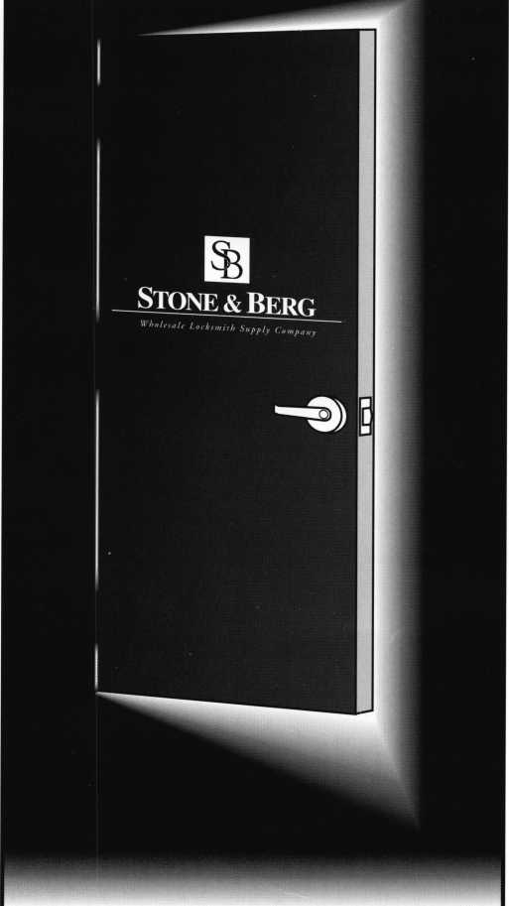
At Stone 8c Berg, we stock a large variety of locksmith
supplies and architectural hardware. With our 24 hour
toll-free fax and no minimum order, you can place your
order at any time of the day or night. Give us a call,
we'll be glad to help, that's the 25 year tradition of ser-
vice and quality you've come to know and trust.
%
Stone & Berg
Wholesale Locksmith Supply Company
'Y (800) 225-7405 • Fax: (800) 535-5625
24hr.Toll-Free
Keynotes \ 11
January 1999
...It’s great when members take an active interest in our facility... especially when they come from so far away...”
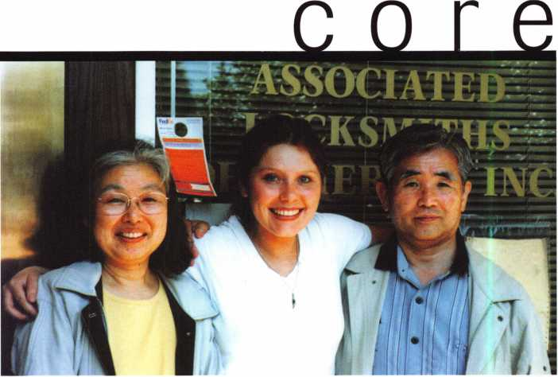

• Surprise visitors
Janelle Vergara was certainly taken off guard while working one Saturday afternoon. The ALOA Meetings and Financial Coordinator had seen three people taking photographs of the ALOA headquarters’ exterior and thought nothing of it. When they rang the doorbell, she soon learned that some ALOA members from Japan had come to visit the facility and take a peek in ALOA’s renowned museum.
“I wasn’t expecting anyone since the office is closed on Saturday,” said Janelle. “When I found out that these people were in town from Japan, I was more than happy to show them around.”
The visitors, Mr. and Mrs. Maeda Yutaka, had made the long trip to Dallas from their home city of Tokorozawa, Japan. Accompanying them was a translator who actually
works right down the street from ALOA’s offices at the Dallas Theological Seminary.
“They were curious about all the presidential portraits hanging in the lobby and were really excited about visiting our lock museum,” Janelle said.
After showing the inquiring couple around the office and museum, Mr. And Mrs. Yutaka had their photograph taken with Janelle and asked a few more questions before leaving.
“It’s great when members take an active interest in our facility,” she said. “Especially when they come from so far away to see where much of ALOA’s operations take place. Most of all, I’m glad that I just happened to be here that Saturday and extend a warm welcome to some very enthusiastic members.”
rnraF
ALOA member Bob Turner from Shelby, Ohio was just named to Board of Directors of the Ohio Burglar and Fire Alarm Association. This is the first time a locksmith has been on the board for that organization. ...Congratulations to the three ALOA members who were recently selected by New Jersey Governor Christine Todd Whitman (R) to serve on the Fire Alarm, Burglar Alarm and Locksmith Advisory Committee, Martin Arnold, CML, Keith Eaves and Richard Rible, CRL
12
Keynotes
January 1999

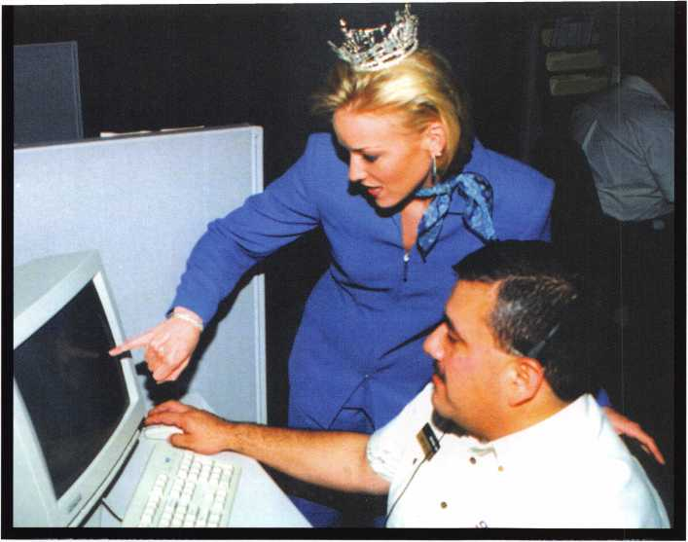
On-Guard technician, Ben Davis, shows Miss Texas, Tatum Hubbard, how the response center operates.
• On-guard, Miss Texas!
Who would have thought that a beauty queen would discover the benefits of the security industry? Apparently, Miss Texas 1998, Tatum Hubbard has enlisted the aid of On- Guard/ATX Technologies in her day-to-day activities.
Hubbard is using the On-Guard Tracker, a satellite and cellular device that provides navigational assistance and security. According to Hubbard, the device has been instrumental in helping her with directions to her promotional appearances as well as letting her parents know where she is at all times.
The On-Guard Tracker has been instrumental in capturing over 100 car thiefs around the
country. This is the second year that the device
• And justice for ALL
Who says image isn’t everything?
Not Black and Decker. The hardware corporation recently walked away winners in a major trademark, trade dress and patent infirngement suit. The losers were Pro-Tech, a Taiwanese-owned company that apparently borrowed the black and yellow trademarks used by Black and Decker’s DeWalt line of power tools.
The U.S. District Court for the Eastern District of Virginia ruled that Pro-Tech had “deliberately and willfully infirnged the DeWalt trade dress and trademark in its yellow and black color combinations.”
Another ruling in the corporation’s favor, found that its patent covering the DeWalt 12 inch compund miter saw was valid and infringed as well.
As a result of the trademark ruling, Black and Decker was awarded $1.7 million, while further briefing has yet to decide the fate of the saw patent issue.
has been used in an official Miss Texas vehicle.
• And the winner is...
Two months ago, we asked for entries to our “Two Of A Kind” contest. So, all of you who had names in common with a celebrity wrote in for a drawing.
The winner was Michael Jordan,
CML #14643 who obviously shares a name with a certain standout basketball player who plays for the Chicago Bulls. Michael (the locksmith, not the ball player) wins four passes to Coney Island Sunlite Pool and Classic Rides. Congratulations! Here are some of the other notable entries:
Jerry Jones, CRL #019608 who shares his name with Jerry Jones, owner of the Dallas Cowboys.
John Day, #027614 who shares his name with John Day dam and John Day River in Oregon (although locksmith Day resides in Vancouver,
Wash.).
Mike Schmidt, #25232 who shares a name with former Phillies’ slugger,
Mike Schmidt.
• Board nominations due April 1
It’s time once again for selected nominations for the ALOA Board. The positions that are to be elected in 1999 are president, directors of southeast, directors of north- central and directors of southwest regions.
Board nomination forms are due by April 1 and are available from the ALOA office in Dallas. Just call (800) 532-2562 or fax (214) 827-1810 to obtain a form or to ask any questions you may have regarding board nominations. The form is also available through Fax on Demand.
Call (310) 575-5074 to receive the most recent form.
• Reader’s choice
Every year, the Keynotes staff selects an “Author of the Year” based on quality of printed articles, quantity of submissions and relevance of information (among other things). Past winners have included such prolific Keynotes scribes as Sal Dulcamaro and Paul Chandler (both of whom are featured in this issue).
This year, we’re going do things a little different and let YOU do the voting.
That’s right, this year’s “Author of the Year” will be selected by you, the readers and the award will be presented at ALOA ‘99 in Cincinnati.
With that in mind, start thinking about the articles you’ve enjoyed since April ‘98 up until March ‘99. The voting ballot will be in the March issue and reminders will be posted in further issues.
Your feedback is instrumental to your publication’s growth and development, so don’t forget to vote this March and don’t hesitate to show up at Cincinnati in July to see if your favorite author wins!
January 1999Keynotes \ 13

execs
Donald J. Harrod recently became the vice president of Engineering at Strattec Security Corporation. ...Susan Poe Flowers is the new president for the Door and Hardware Institute. ...Fred Gllidi has been promoted to the position of regional sales manager for Wells Lamont Industrial. ...Jerome Andrews has been appointed IDN’s sales and technical services representative for the state of Ohio.

prp
CRL
David K. Spears, Delaware, Ohio

regions
The Central to Southern Colorado Locksmith Association (CSCLA) is holding its next two regular meetings on January 15 at 7 pm and February 19 at 7 pm.
The Association of Ontario Locksmiths will sponsor a class entitled Basic Safe Servicing January 9—10 and a course in Panic Exit Devices on January 23—24.
The Cowboy Locksmith Wyoming Locksmiths Association will hold its winter meeting Janury 8—10. Also, on January 9, Ray D’Adamo will present a special class on Motorcycle Locksmithing
(Editor’s note: Would you like to see your regional association’s activities represented in Keynotes? Just fax all coirespondence to 214-827-1810 or email to: keynotes@anet-dfw.com.)

• obituaries
As we begin a new year, ALOA has to say goodbye to some its dearest friends. The following were dedicated members who were vital to the association’s progress over the years.
Irving Perlman had been a member for 13 years. A hard worker, his skills and energies were devoted to his work at Perlman Associates. Irving was 80 years old.
Samuel Solomon, RL was a leading figure among Michigan locksmiths. His involvement in Michigan associations and ALOA will be remembered by all of his friends and colleagues. He was a member for 30 years. Samuel was 77-years-old.
Donald Shultz, CML had contributed to Alert Locksmith and Security and was a member of ALOA for 22 years. He was 71-years-old.
Joseph Willitzer, RL was a member for 28 years. He worked at Rex Locksmith and resided in El Sobrante, Calif. He was 70-years-old.
B. Lewis Jeffers, RL was a force behind Englewood Lock & Safe and was a member of ALOA since 1973. He was 83-years-old.
At press time, Keynotes has learned that industry giant, Harry C. Miller has passed away at the age of 86. He was the founder of Lockmasters and the former CEO of Sargent and Greenleaf. He was fondly referred to as the father of manipulation. Look for additional information on ALOA’s web page (www.aloa.org) as well as in the February issue of Keynotes.
14 | Keynotes January 1999
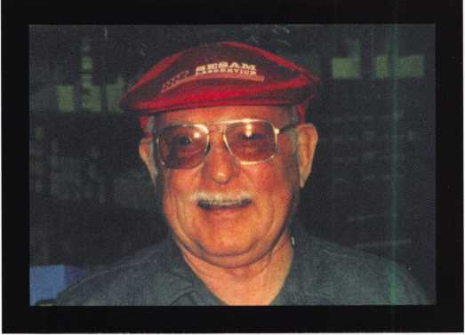

• Farewell to Fuher
On Sunday, December 13 1998 Stan Fuller died from
complications associated with multiple illnesses. Stan leaves behind
his loving wife Betty and their three sons. Those of us who knew him
best recognize that Stan’s life had far reaching significance, touching
many of us in a way no other industry giant had ever achieved.
Stan was known by many as the technical support arm of the
former Allied-Gary Safe Company. During his tenure there, Stan’s
duties included technician support, product information, design and
development of the Allied-Gary safe line of product. In earlier years,
Stan spent many years rigging vault equipment, repairing and
opening vaults, safes and chests made by the known greats of the era.
Many of my conversations with Stan delved into the wonders of
HHM Five-Star Constellations, the genius of Remington-Sherman,
the diabolical Maganese Bank Chests and the mind’s eye of the early
safe and vault manufacturer. Paramount and what I consider Stan’s
highest achievement was his love of industry related education.
Known by many students throughout world, Stan set standards of
excellence in education that stand as the ruler by which all other
programs are measured. In addition to instructing Gary Certification
classes, Stan taught basic vault door rigging, combination lock
servicing, diagnostic safe opening and penetration.
Stan’s life was multi-faceted and included a side most of our
industry never had the opportunity to experience first hand. Stan was
a master woodworker, demonstrating a level of skill not exhibited by
the majority of his contemporaries. His work in wood included
functional safes and chests in miniature, large furniture and custom
wood carving. In his retirement, Stan continued to design safes, field
questions and devise methods for more efficient, trouble-free manu-
facture. As often as time would allow, fly-fishing was his third
passion. Stan was an expert fly fisherman who taught many the art of
tying a fly and how to cast with success. In his death, I celebrate his
life as my friend, my family and one of the last politically incorrect
safemen. For whatever reason, Stan saw value in my life and made it
his business to make my life better and richer for
knowing him. Our last visit was April 1998.
During that visit, Stan brought me a custom-
made wooden miniature of a Rosengrens chest and
instmcted a one day class in Gary Safe Technology.
Rest well my friend.
— Dan Graffeo
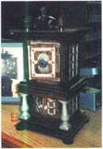

^psgf UNITED STATES BSM1 POSTAL SERVICE™
Statement of Ownership, Management, and Circulation
(Required by 39 USC 3685)
1. Publication Title | 2. Publication Number |  |  |  |  |  |  |  |  | 3. Filing Date
KEYNOTES | 0 | 2 | 7 | 7 | - | 0 | 7 | 9 | 2 | 11/24/98
4. Issue Frequency  Monthly except for July/Aug issue | 5. Number of issues Published Annually 11 |  |  |  |  |  |  |  |  | 6. Annual Subscription Price Member Benefit
7. Complete Mailing Address of Known Office of Publication (Not printer) (Street, city, county, state, and ZIP+4) |  |  |  |  |  |  |  |  |  | Contact Person
3003 Live Oak St. Dallas, TX. 75204-6186
Anne Davis
Telephone
(214) 827-1701
8. Complete Mailing Address of Headquarters or General Business Office of Publisher (Not printer)
Associated Locksmith of America Inc (ALOA)
3003 Live Oak St. Dallas, TX. 75204-6186
9. Full Names and Complete Mailing Addresses of Publisher, Editor,.and Managing Editor (Do not leave blank)
Publisher (Name and complete mailing address) ____
SAME AS ABOVE
Associated Locksmith of America (ALOA) 30Q3 Live Oak St. Dallas, TX. 75204-6186
Editor (Name and complete mailing address)
Anne McDonald Davis
Associated Locksmith of America Inc. (ALOA) 3003 Live Oak St. Dallas, TX. 75204-6186
Managing Editor (Name and complete mailing address)
Mike Emery
Associated Locksmith of America Inc. (ALOA) 3003 Live Oak St. Dallas, TX. 75204-6186
10. Owner (Do not leave blank, if die publication is owned by a corporation, give the name and address of the corporation immediately followed by the names and addresses of all stockholders owning or holding 1 percent or more of the total amount of stock, if not owned by a corporation, give the names and addresses of the individual owners. If owned by a partnersNp or other unincorporated firm, give its name and address as well as those of each individual owner. If the publication is published by a nonprofit organization, give its name and address.)
Full Name | Complete Mailing Address
Associated Locksmith of America Inc. | 3003 Live Oak St. Dallas, TX. 75204-6186
11. Known Bondholders, Mortgagees, and Other Security Holders Owning or
Holding 1 Percent or More of Total Amount of Bonds, Mortgages, or
Other Securities. If none, check box — - ■—► £3 None
Full Name | Complete Mailing Address
12. Tax Status (For completion by nonprofit organizations authorized to mail at spaded rates) (Check one)
The purpose, function, and nonprofit status of this organization and the exempt status for federal income tax purposes: Of Has Not Changed During Preceding 12 Months
□ Has Changed During Preceding 12 Months (Publisher must submit explanation of change with this statement)
PS Form 3526, September 1995
(See Instructions on Reverse)
13. Publication Title  KEYNOTES |  |  | 14. Issue Date for Circulation Data Below  October '98
15. | Extent and Nature of Circulation |  | Average No. Copies Each Issue During Preceding 12 Months | Actual No. Copies of Single Issue Published Nearest to Filing Date
a. Total Number of Copies (Net press run) |  |  | 9500 | 9500
b. Paid and/or Requested Circulation | (1) Sales Through Dealers and Carriers, Street Vendors, and Counter Sales (Not mailed) |  | 0 | 0
 | (2) Paid or Requested Mail Subscriptions (Include advertiser's proof copies and exchange copies) |  | 8500 | 8347
c. Total Paid and/or Requested Circulation (Sum of 15b(1) and 15b(2)) |  | ► | 8500 | 8347
d. Free Distribution by Mail (Samples, complimentary, and other free) |  |  | 50 | 50
e. Free Distribution Outside the Mail (Carriers or other means) |  |  | 300 | 400
f. Total Free Distribution (Sum of ISd and 15e) |  | ► | 350 | • 450
g. Total Distribution (Sum of 15c and 15f) |  | ► | 8,850 | 8797
h. Copies not | (1) Office Use, Leftovers, Spoiled |  | 650 | 703
Distributed | (2) Returns from News Agents |  | 0 | 0
i. Total (Sum of 15g, 15h(1), and 15h(2)) |  | ► | 9500 | 9500
Percent Paid and/or Requested Circulation (15c/15gx 100) |  |  | 96% | 95%
16. Publication of Statement of Ownership _{T}_ _{n} i q q
GL Publication required. Will be printed in the \J , py
D Publication not required.
_ issue of this publication.
17. Signature and Title of Editor, Publisher, Business
Ca/vvW v /VV<
igar, or Owner
w /z.w/£5r
I certify that all information furnished on this form is true and complete. I understand that anyone who furnishes false or misleading information on this form or who omits material or information requested on the form may be subject to criminal sanctions (including fines and imprisonment) and/or civil sanctions (including multiple damages and civil penalties).
Instructions to Publishers
- Complete and file one copy of this form with your postmaster annually on or before October 1. Keep a copy of the completed form for your records.
- In cases where the stockholder or security holder is a trustee, include in items 10 and 11 the name of the person or corporation for whom the trustee is acting. Also include the names and addresses of individuals who are stockholders who own or hold 1 percent or more of the total amount of bonds, mortgages, or other securities of the publishing corporation. In item 11, if none, check the box. Use blank sheets if more space is required.
- Be sure to furnish all circulation information called for in item 15. Free circulation must be shown in items 15d, e, and f.
- If the publication had second-class authorization as a general or requester publication, this Statement of Ownership, Management, and Circulation must be published; it must be printed in any issue in October or, if the publication is not published during October, the first issue printed after October.
- In item 16, indicate the date of the issue in which this Statement of Ownership will be published.
- Item 17 must be signed.
Failure to file or publish a statement of ownership may lead to suspension of second-class authorization.
PS Form 3526, September 1995 (Reverse)

Among the products in Kwikset’s Titan line is a commercial grade keyed entry lever. This grade 2 lockset is shown separated into parts in photo 1. The Titan lever handle lock does not require additional mounting holes above and below the main cross bore hole, as is found on many other commercial grade lever handle locksets. Although the various parts are of heavier and stronger construction, the internal layout and design of the latch and mechanical operation is quite similar to the Kwikset residential locksets.
Photo 2 shows the UL rated latch in front of the external lock assembly. The traditional half moon shape of the actuating mechanism of the lockset and the matching opening in the latch (in which it interacts) is nearly identical to the layout of Kwikset residential knob locks. This latch is UL fire rated (unlike residential lockset latches) and can be used on “A” label 3 hour fire rated doors.
Assembly will be illustrated without attachment to a door so that the internal parts can be viewed. The latch is installed first into the edge bore hole of a door. The outer lock assembly with its central spindle/actuating mechanism and two screw attaching posts (one to each side of the spindle) fit through matching openings in the latch, which is shown in photo 3. The interior assembly is shown to the right of photo 4. A matching half moon shaped opening is also in this part, which requires that it be positioned properly. If it is reversed it will not assemble. With the interior assembly attached, in photo 5, two mounting screws are started and tightened. An additional screw, shown in photo 6, is required for UL/ULC (UL- Canada, I presume) rating. It is inserted in the open hole at the top of the interior assembly. Photo 7 shows the screw bridging the gap between the interior and exterior assemblies.
I am not sure of the specific purpose of this screw, but (unlike the mounting screws) the threads of this screw grip into the metal of both the interior and exterior assemblies. When fully tightened, the screw will not allow the interior and exterior assemblies to move closer to or further from each other.
The cover (or rose), shown in photo 8, is intended to conceal the attaching screws and provide a more attractive appearance on the interior side of the lock. After all the screws are tightened, the cover snaps onto the interior assembly in photo 9. Then the interior lever handle is ready for assembly. There is a spring loaded catch (or retainer) that must be depressed in order to install the lever. A matched position access hole (in line with the retainer) can be seen in the neck of the lever handle. When the lever handle is installed, the catch will protrude through the access hole and secure the lever handle until the catch is again depressed for future disassembly. The lock is fully assembled in photo 10.
LOCK CYLINDER SERVICING
Like the residential Titan product line, the Titan commercial series lever lockset also uses a key removable cylinder. The method and constmction are different, and there is no interchangeability between the residential and commercial lock cylinders. They can be keyed
16 I KeynotesJanuary 1999

Titan Comr
alike because they use the same type of key. The cylinder removal keys are of a different design, and there is no one removal key that will work with both residential and commercial series Titan products. That remains the case, even when dealing with operating keys with the same bitting pattern. When keying alike residential and commercial series Titan locks, separate cylinder removal keys must be made for each category of lock.
Photo 11 shows a Titan commercial series key removable cylinder on the left. To the right is an example of a similar cylinder for the previously discontinued Kwikset premium commercial series lever handle locksets. Operating keys and cylinder removal keys for the cylinders are just to the outside of each cylinder. The cylinders are very similar in appearance, and the operation and servicing of each is nearly identical.
Like standard Titan products, the cylinder removal key involves the duplication of the operating key bitting cuts onto a specially designed (removal) key blank. For standard Titan items, the key blade is the same for a removal key as an operating key, except for a notch nearly midway on the bottom of the blank. When the plug is rotated to a designated position, a retainer is able to move into the slot in the bottom of the removal key to allow the cylinder to be removed. A normal operating key (with solid metal in the spot where the removal key is notched) keeps the retainer pushed outward so the cylinder doesn’t come out during normal lock operation.
Both the earlier style Kwikset commercial levers and the newer Titan commercial series lever use an extended length key as its cylinder removal key. The operating key cuts are duplicated onto the cylinder removal key blank, and that becomes a removal key for that lever lock and others with the same bitting pattern. Photo 12 shows a front view of both cylinders. Both are six pin cylinders, but the blade of the operating key for the Titan cylinder has a shorter length from the top shoulder to the tip of the key. The length of the key blade from the bottom shoulder of both keys is identical. The slightly wide opening at the top of the Titan cylinder keyway allows the top shoulder of the key to go slightly further into the plug than the actual face surface of the plug. The top shoulder of a Titan key (when fully inserted) is a minute distance from the pin in the first pin chamber.
Measuring from the actual face of the plug, the distance to the first pin chamber of both cylinders is the same. The intended advantage of the Titan system key is that the top shoulder will recreate the standard spacing of five pin Kwikset cylinders, allowing a Titan key to operate those locks, too. The closely spaced (right up to the shoulder) first cut of a Titan key would have no purpose in a standard spaced five pin Kwikset cylinder. Instead the last five (of six) cuts on a Titan key would coincide with the five cuts of a standard Kwikset key.
The commercial series Titan removal key travels the full length of the cylinder plug. Photo 13 shows the Titan cylinder with the removal key full inserted and rotated 180 degrees. The tip of the key can be just barely seen in the center slot at the back end of the cylinder plug.

nercial Series
Lever Handle Lock
by Sal Dulcamara, CML
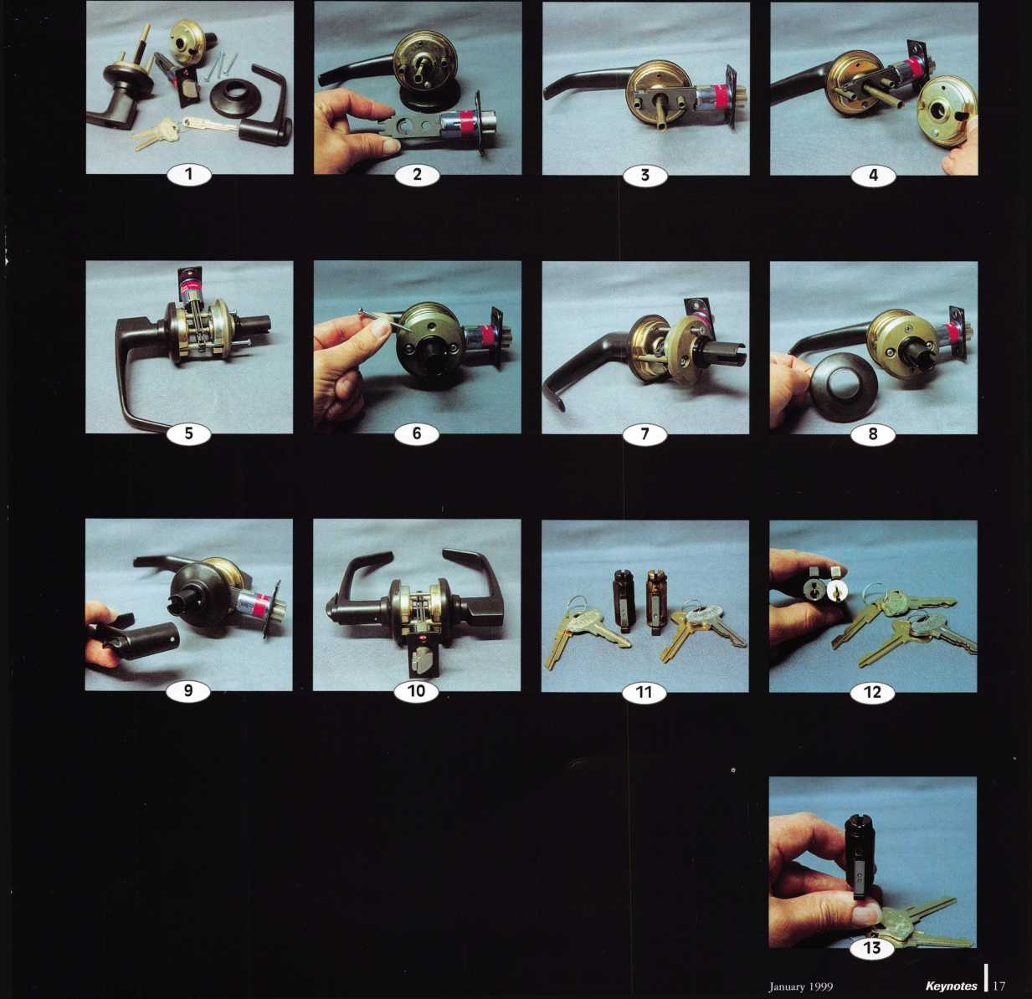

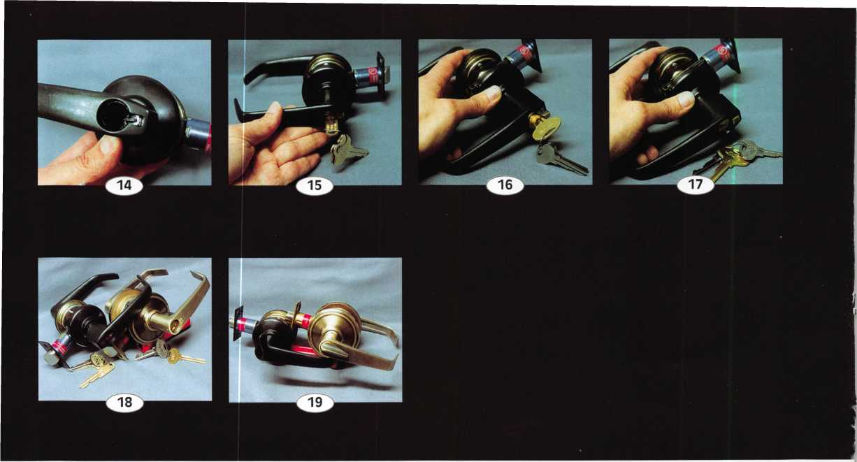
The part with which it makes contact can be seen in photo 14, at the back of the empty cavity from where the cylinder was removed. The protruding blade or actuating mechanism is spring loaded. During normal operation, the slot at the back of the plug fits over the top of that piece. The shorter length operating key doesn’t reach far
MLANJ 1999
Annual Convention
March 18th thru March 21st
Somerset, New Jersey
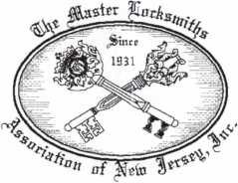
For More Information:
PO Box 2441
Morristown, NJ 07962-2441
Phone 973-267-8884
Fax 973-538-2248
Or visit our web site at
www.MLANJ.org
18 I KeynotesJanuary 1999
4 I J
enough down to push it in and disengage it from the cylinder. Instead, the operating key rotates it roughly one quarter turn in either direction to lock or unlock the Titan lockset. When the removal key contacts that part and disengages it from the end of the lock cylinder, the cylinder is able to rotate the needed full half turn in either direction. A half turn rotation positions the cylinder for easy insertion or removal.
Photo 15 shows the cylinder (with plug rotated 180 degrees) being inserted into the cylinder cavity of the lever handle.
The older style Kwikset key removable cylinder actually fit into the Titan commercial lever. It has been partially inserted in photo 16. When fully inserted, it’s partly protruded from the face of the lock as can be seen in photo 17.
Other differences between the older Kwikset commercial lever and the newer Titan commercial series include the orientation of the keyway. Photo 18 shows the Titan lever side by side with a Kwikset commercial lever. Although both keyways point side to side instead of top to bottom, they point in different directions when installed on the same handed door. Both locks are positioned as if mounted on a left hand door, with the lever handle pointing left to the hinge side. The Titan lever (on the left) has its cylinder with the top of the keyway pointing to the opening (latch) side. The older style Kwikset lever (on the right) has its cylinder with the bottom of its keyway pointing to the latch side. Both have ADA accessible interior turn pieces. Photo 19 shows the extended length turn pieces that can be easily rotated without grasping them.
Titan commercial series levers come standard with the standard Titan key cylinder. Two other optional cylinders are supposed to be currently available: one with the standard five cut Kwikset key, and one for the standard Schlage C keyway. The Titan commercial series levers should probably be available from your suppliers that stock residential Kwikset and Titan lock products.

OA Branches Out
Comment
by Tim McMullen

EFFORTS TO PROMOTE THE LOCKSMITH INDUSTRY
What an exciting year this is going to be for ALOA. We are “that close” to agreeing with NBFAA on definitions for the industry that should put to rest all those nasty alarm bills that have pulled our members in unnecessarily. With that issue on the back burner (but it’s still one we ALWAYS will keep an eye on), ALOA is almost ready to unveil an aggressive government relations program that focuses on generating more business for our members.
Tax breaks and property insurance reductions for the consumer installing particular locks are effective ways to promote the locksmith business. These types of bills have already been successfully introduced in New York (A489; A8590; A3974). The proposed legislation will permit a state income tax deduction for home security devices (including locks) installed by a bona fide locksmith.
The availability of model laws from ALOA will give locksmiths a positive vehicle in which to visit their own state senator and representative. If you are interested in promoting such legislation in your state, just follow these simple steps:
- Obtain a copy of the model law and press kit from the ALOA office.
- Coordinate ALOA chapters and state or regional locksmiths associations so that everyone in the state is on board.
- Identify people who are willing to work on such a project. This would include visiting their state senator and representative to have them introduce the bill. Lobbying the general assembly: paying special attention to the committee the bill was assigned and give testimony promoting the legislation through the media.
- Rally the troops in your state to write letters and make phone calls in support of the bill.
This is an exciting opportunity for locksmiths not only in promoting their business, but also is a great public relations tool.
To obtain more information regarding this new program, please join the Legislative Action Network (see below.) Oh, what a difference a year makes!

LEGISLATIVE UPDATES
NEW JERSEY
CORRECTION: In the December issue of Keynotes, under “Legislative Comment,” in “Legislative “Carry-Over,” under “New Jersey A2104/S 1059” it states that “sales reps, automotive service dealers, and trade unionists are exempt from the licensing law P.L. 1997 c.305, through proposed bill A2104/S1059.” The proposed bill was misinterpreted. The bill intends to, in section eight, remove the words “mechanical” and “as part of a new building construction or renovation project.” This would exempt trade union members. The other entities mentioned are not exempt, the activities of these persons in performing their tasks and related to their tasks are exempt.
NEW YORK
Bill Number: A 11425, Date Introduced: 07/21/98
Status: SENT to Committee on Consumer Affairs and
Protection
Summary: Requires locksmiths to obtain identification from a
person requesting the performance of an opening of residential or commercial premises, safes, vaults, and motor vehicles and to keep records and to provide access to records by law enforcement officers.
Bill Number: A 3974, Date Introduced: 02/10/97
Status: Recommitted to Committee on Ways and Means.
Summary: Permits a state income tax deduction for home security devices (including locks) installed by the owner occupant of a one, two or three family home for an amount not to exceed five hundred dollars. Sponsor: Hill Bill Number: A 489, Date Introduced: 01/08/97 Status: Recommitted to Committee on Ways and Means
Summary: Grants an income tax credit for certain private security devices in a dwelling unit. Sponsor: Lafayette Bill Number: A 5315, Date Introduced: 01/20/98 Status: AMENDED and RECOMMITTED to Committee on
Housing.
Summary: Establishes security requirements to be fulfilled by
owners of multiple dwelling units including deadbolt locks, window pins, adequate lighting, solid core door and optical viewers. Sponsor: McLaughlin Bill Number: A 8590, Date Introduced: 07/17/97 Status: To Assembly Committee on Ways and Means.
Summary: Provides for a possible tax credit in cities of one million or more for security improvement measures or enhancements made in class 2 dwellings; authorizes a one-time credit of up to 20 percent of the cost of such measures or enhancements; includes, but is not limited to, the employment of security guards, and the installation of enhanced lighting, monitors, locks, fences or other improvements designed to enhance security.
ALSO SB 4880.
Bill Number: S 2130, Date Introduced: 02/04/97
Status: Recommitted to Senate Committee on Housing,
Construction and Community Development.
Summary: Requires intercommunication systems and automatic self-closing and self-locking doors in class A multiple dwellings with eight or more apartments.
Sponsor: Mendez.
RHODE ISLAND
Bill Number: HB 7376. Date Introduced: 01/20/98
Status: Tabled in Labor Committee
Summary: Relates to the licensing and regulation of locksmiths.
Based on ALOA Model Law. Sponsor: S. ANDERSON. Also SB2303. Sponsor: FLYNN.
Bill Number: HB 8660, Date Introduced: 02/25/98
Status: Transferred to House Committee on Finance
Summary: Deletes current Burglar and Hold-Up alarm Business statute, and places all regulation and rule-making in the hands of the director of the department of business regulations. Sponsor: Kennedy.
If you are interested in working on legislative issues, fundraising or gathering/giving information on legislation that effects your industry, call ALOA Fax-On-Demand (310 575-5074) and request document #15.

JOIN THE ALOA LEGISLATIVE ACTION NETWORK
January 1999
Keynotes
19
During the early part of my locksmithing career, I was working out
of Albuquerque, New Mexico. Those first four years found me working
on very old safes. These safes were graced with beautifully crafted brass
and bronze locks and bolt works. It was an unbelievable time for
learning and exploring the profession.
I was taking broken linkage of the safe works and rebuilding the
mechanisms that were no longer manufactured, which allowed me to
be as much a machinist as a locksmith. Using caustic strippers, I
removed paint and tarnish that had accumulated over the years. I also
used rubber gloves and most of the work was
performed in an outside yard.
After the stripping was done and the parts
were rinsed, then came the polishing and then
the varnish. The varnishing of the parts would
keep them clean and sparkling for many years
without any significant care required.
It is needless to say that this was a
dangerous and, in many cases, an unnecessary
effort. A lot of the parts did not need to be
that beautiful. Being functional was of the
utmost importance. Thoughts of functionality
over beauty are fine, for a safe and its internal
workings, but what about the care and
restoration needed for the homeowner who
wishes to make improvements? These
improvements entail taking the hardware that
is in existence and making it look and
function like new, not going out and
purchasing new hardware.
I have spent over 20 years in the Northeast
Tennessee and Northwest North Carolina
areas and the business of restoration of antique
locks is an important segment of business.
Homeowners want and are willing to pay for
someone to enter their home to rebuild, clean
and polish their hardware. This is primarily
true in large homes that were built before the
1950s. The locks are primarily mortise with
pin tumbler cylinders and ornate escutcheons.
They usually have very detailed and beautiful
knobs or levers that compliment the
escutcheons. The jobs entail rebuilding the
springs and internal pieces that have broken
or worn to a point that proper function has
either stopped or is inhibited.
Rebuilding these items is a very satisfying
undertaking. It may also be a very fmstrating
encounter. It is a very true fact that good help
is hard to find! A good craftsman is even
harder to find. If you are not a machinist then
you will have to find one who is willing to
work with brass and bronze. You may even have to find a metal works
that will help you to procure blocks of brass for raw materials. A lot of
this will depend on how self-sufficient your machinist or welder may
be. There are many things to consider before you jump into this
lucrative endeavor of restorations. One of the most critical is having an
arsenal of outsourcing craftspeople.
There are times on a small job that I will consider doing the stripping of the tarnished, half-lacquered finishes. I, the employer, will do the work and not any employees. OSHA (Occupational Safety and Health Administration) is a government organization that makes people and businesses very wary and careful. They are in the business of
protecting the environment and employees. The stripping agents that
are used in restoration work are very caustic and a respirator is but one
example of protection that is required. This is not the cloth cup over
the face item for $1.50 from your local paint or hardware store. OSHA
says that the National Institute of Occupational Safety and Health
(NIOSH) must approve the respirator.
There are more headaches and bad news just with respirators! You
must provide the respirators, medical evaluations of the employees who
use the respirators, a written respirator program, a training program,
and that’s just the beginning! You must
provide your facility with proper ventilation,
flooring and disposal methods and employees
must also have proper clothing. Woe is it to
the employers who think that OSHA
standards do not apply to them. In 1997,
OSHA found a total of 87,710 violations and
levied $89,447,893 in penalties. With the
help of individual states, another 147,610
violations were found and $48,407,539 in
penalties was rendered. My evaluation is that
renovation work is not a profitable effort for
the average locksmith unless you outsource
your work through your contacts.
There is a company that can be your savior
in this type of work. A1 Bar Wilmette Platers
of Wilmette, Illinois was established in 1937
as a silversmith shop. They work with
everyone from the homeowner to the
contractor and architect in restoring metal
articles. This means fabrication to finishes. If
your lock has a broken piece in it, they will
make one or find one in their stock. If you
only have one knob, they will cast you
another. They work in brass, bronze, copper,
nickel, chrome, silver, gold and also in some
special finishes such as antiquing and pewter.
If it is an exterior lock they will try to
bring it into the work area and back out in
the same day. Should you send them interior
locks it will take anywhere from 2 to 4 weeks.
It is important to know that the cost is always
based on a custom work scale. There is not a
set fee that is charged for any job and until
they see the item that needs restoration, they
will not give you a quote. They will work
with each customer on an individual and
personal basis. There are not many of these
businesses and this is one contact option that
you should not be without.
You will find that as you step into this new
world of renovations that the homeowner will
come to you for other items as well. It may be a light fixture, or light
cover switch plates, cabinet hardware and even wall sconces. Whatever
it may be, you should remember that the money is good and you can
have a little fun while you are at it. One of my favorite things to do is
to have a list of needed items and make a trip to a large town and visit
the salvage yards. The visits also afford you a short but enjoyable tax
deductible vacation if you want to plan it properly.
There is not a practical price list that can be given for you to price
your efforts and work. Know that it takes your time, effort and money
to successfully pull everything off. Among the tasks required for a
proper job are making the phone calls, taking photographs and having
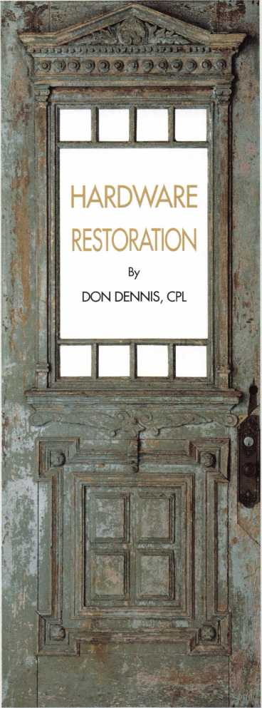
Keynotes
January 1999

them printed, visiting salvage yards - and keeping up good relationships with the owners and employees - and mailing off the hardware and getting it back. Then there is the work of on-site efforts in dealing with the materials. All of this needs to be considered into your price. You will find a good list of dealers and other custom businesses in the source lists with this article. Take these as a beginning and find more. There are a lot of magazines on the market that you can pick up at your local bookstore. Two of my favorites are the Old-House Journal and Old-House Interiors. There are many more besides these to choose from.
Before I conclude this article, I should impart a little bit of information on finishes. The new finishes being touted by the industry of bathroom hardware as well as in our own industry of lock hardware, are a true technology that was nonexistent just a few short years ago. The terminology for this technology is what is being called Physical Vapor Deposition (PVD). The finish of a non-tarnishing brass may consist of any sort of underlying base metal that has been chromed followed by a ceramic colored coating and then strengthened by a titanium nitrate or similar coating. All of the coatings have different color qualities and are used in combination to provide not only color but also either strength or toughness. Once combined they give the consumer a quality product without the hassles of having to take a lot of care in upkeep. Yes, this is all fine and good but what is to be done for the finish that is of original brass and was not produced within the past few years?
Most of the stripping agents that can be purchased at your local hardware store will have Methyl Ethyl Ketone as the primary active
RESOURCE LIST
ANTIQUE REPRODUCTION-Cabinet and furniture hardware
HORTON BRASSES, INC. - P.O. Box 120, dept OHJ, Cromwell, CT 06416; phone (860) 635-4400; www.horton-brasses.com; catalogue $4.00.
ARCHITECTURAL SALVAGE
OLDE GOOD THINGS - 124 West 24th Street, New York, NY 10011; phone
- 989-8401; fax (212) 463-8005; www.oldegoodthings.com. ARCHITECTURAL SALVAGE, INC. - Brentwood, NH 03833; phone (603) 642-4348.
OLD HOUSE JOURNAL — for entire company focus visit web site: www.oldhousejoumal.com; email www.hbrnet.com.
DOORS-Made-to-Order
CRAFTSMAN DOORS - 2204 San Pablo Ave., Berkeley, CA 94702; phone (510) 843-3636; fax (510) 843-0666; starting at $775.00. DOOftS-Screen, nraeide»f®-@rd©r SCREEN SCENES - P.O. Box 3625, Quiney, CA 95971.
G-U HARDWARE, INC. - 11761 Rock Landing Drive, Suite M6,
Newport News, VA 23606; phone (757) 873-1097; fax (757) 873-1298; www.g- u.com
DOOftS-Garage, hand-crafted for vintage and designer homes DESIGNER DOORS, INC. - 1-800-241-0525; www.designerdoors.com HARDWARE RENOVATORS
AL BAR WILMETTE PLATERS -127 Green Bay Road,
Wilmette, IL 60091; phone (847) 251-0187, fax (847) 251-0281 HARDWARE SUPPLIERS-ANTSQUi EUGENIA’S - 5370 Peachtree Road, Chamblee, GA 30341; phone 1 800 337-1677; catalog $1.00.
HEALTH AND SAFETY
CANADIAN CENTRE FOR OCCUPATIONAL HEALTH & SAFETY - http://www.ccohs.ca./
OCCUPATIONAL SAFETY & HEALTH ADMINISTRATION - http://www.osha.gov/
PUSH-BUTTON LIGHT SWITCHES
CLASSIC ACCENTS — 17810 Telegraph Rd, dept OH, Brownstown, Twp, MI 48174; phone (313) 941-8011
chemical that does the work of dissolving varnish and tarnish. The Canadian Center for Occupational Health & Safety has a good Internet web site that will give you a good documentation on this chemical. Personally, I do not wish to use a lot of it on a daily or even weekly basis. Again let me say that for a small job, I would use it. I would never let my employees close to it.
When it comes to polishing, employees come to the forefront! The removal of tarnish from brass is not difficult. You need an acid, a bonding agent and grit. The grit can be sand, pumice, or even salt.
The bonding agent can be flour, cream or even mud and the acid could be vinegar or citrus. There are a lot of home remedies that can be concocted but in recent years there has been a product called Fast Orange hand cleaner. It is wonderful stuff! Not only for your hands but for brass as well! I have a tub of it and simply plunge the brass item into the tub to submerge it. Leave it for 10 minutes or so, and with a dry cloth, rub the surface and then rinse it off with water. I use rubber gloves when doing a lot of this work at any given time. The cleaner will strip your own skin of all of its oils leaving you with a very unpleasant feeling that will require lots of hand creams to replace the lost oils. After the polishing, you are down to the spray varnishing of each brass item. Again, this needs lots of ventilation and will have an impact dealing with OSHA. This would not be a task for any of my employees. I realize that each of us march to the beat of a different drummer. I will stick to my list of resources and make good money letting others worry about OSHA. It is my belief that this makes good business sense.
SALVAGE SUPPLIERS
ADMAC SALVAGE - 111 Saranac St., Littleton, NH 03561; phone (603) 444-1200 www.musar.com/Admac/
ARCHITECTURAL SALVAGE, W.D. - 614-618 E. Broadway, Louisville, KY 40202; phone (502) 589-0670; www.architecturalsalvage.com/ ARCHITECTURAL SALVAGE, INC. - 33 Peabody Dr., Brentwood,
NH 03833; phone (603) 642-4348; www.oldhousesalvage.com/
BRASS KNOB - 2311 18th St. NW, Washington D.C.20009; www.washingtonpost/yp/brassknob/
THE EMPORIUM - 1800 Westheimer, Houston, TX 77098; phone (800) 528-3808; www.the-emporium.com/
FIRST SATURDAY CONSTRUCTION SALVAGE - Rt 3, Box 405, Spencer, IN 47460; phone (812) 876-6347; www.constructionsalvage.com/
FONTAINE’S AUCTION GALLERY - 1485 W. Housatonic St., Pittsfield, MA 01201; phone (413) 448-8922; www.fontaineauction.com/
HIPPO HARDWARE & TRADING - 1040 E. Burnside St., Portland OR 97214; phone (503) 231-1444; www.hipponet.com/
MATERIALS UNLIMITED - 2 West Michigan Ave., Ypsilanti, MI 48197; phone (800) 299-9462; www.mat-uni.com/
OLDE GOOD THINGS - 124 West 24th St., New York, NY 10011; phone (800)303-4407; www.oldegoodthings.com/
OLD HOUSE PARTS CO. - 24 Blue Wave Mall, Kennebunk, ME 04043; phone (207) 985-1999; www.oldhouseparts.com/
RECYCLING THE PAST - 381 N. Main St., Bamegat, NJ 08005; phone (609) 660-9790; www.recyclingthepast.com/
SALVAGE ONE — 1524 S. Sangamon St., Chicago, EL 60608; phone (312)733-0098; www.salvageone.com/
SHAMBALLA - 207 Shelby St., Santa Fe, NM 87501; phone (505) 820-0866; www.asianart.com/shamballa/
TIM & BILLY’S SALVAGE STORE - 970 Ft. Wayne Ave., Indianapolis,
IN 46202; phone (317) 632-7161; www.architechturalantiques.net/
TIMBER & STONE - 5431 E. US Hwy 290, Fredricksburg, TX 78624; phone (800) 847-2944; www.timberandstone.com/
UNITED HOUSE WRECKING - 535 Hope St., Stamford, CT 06906; phone (203) 348-5371; www.united-antiques.com/
January 1999
Keynotes | 21

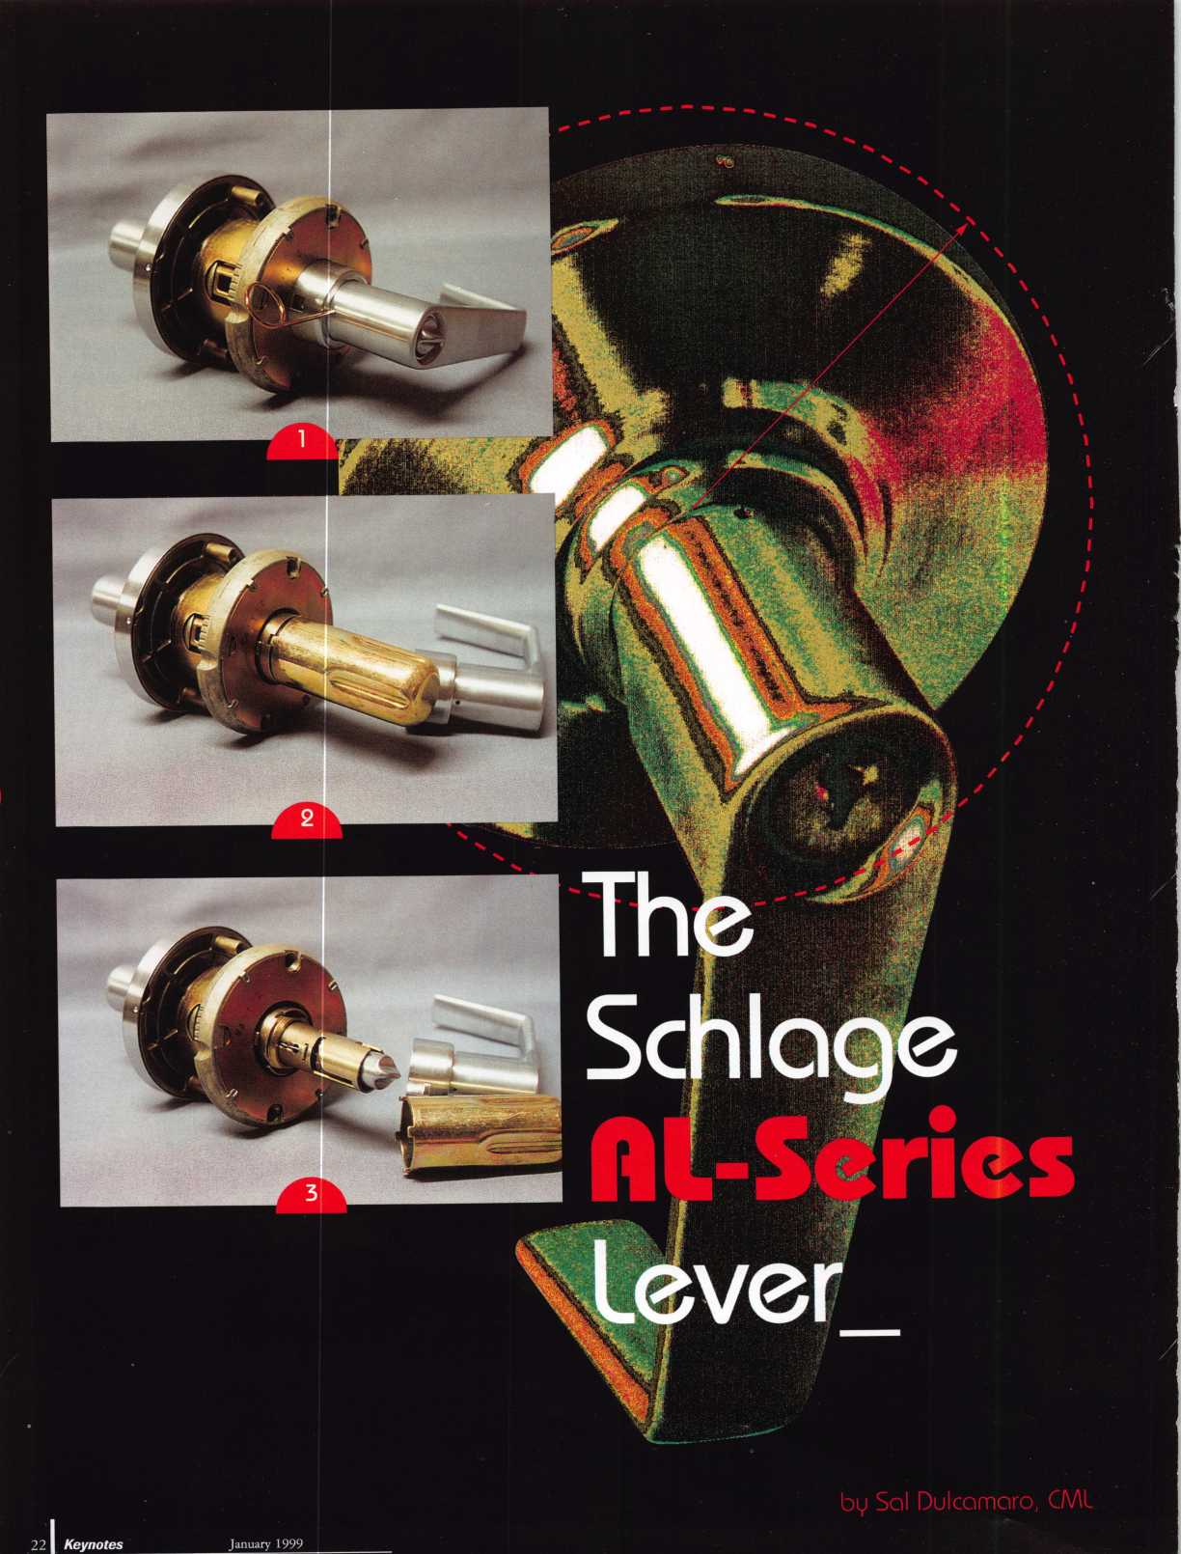

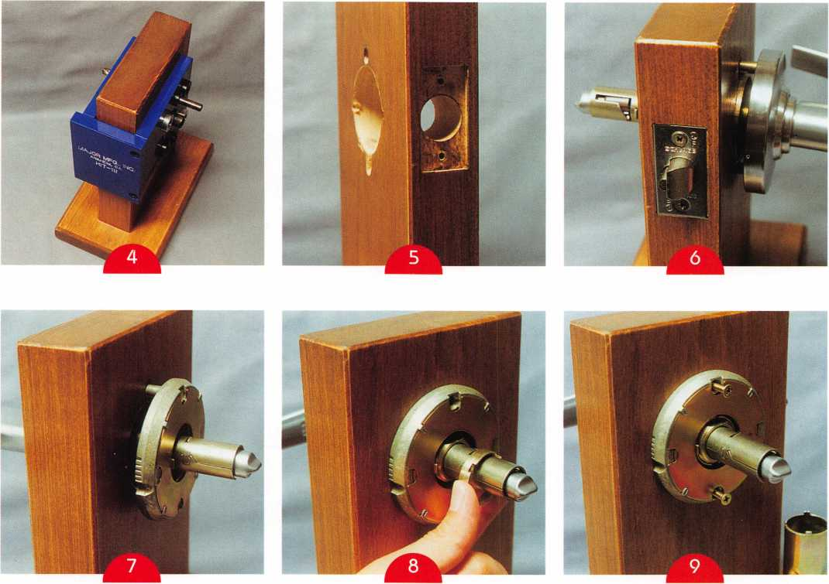
The Schlage AL-series key-in-lever lockset is just one of many different lever handle locksets manufactured by Schlage. There are lighter duty residential type locksets and on the higher end is the grade one Rhodes lever. The AL-series locksets are the lever handle equivalents of the Schlage A series commercial knob locks. The AL- series are also standard duty commercial grade 2. Although both are grade 2, the lever handle lock must be physically stronger (involving new and different additional lock components). The greater accessibility, designed for ADA disability requirements, helps not only ease access by disabled persons but likewise for burglars. The built-in leverage of a lever handle lock forces the manufacturer to beef it up compared to an ordinary knob style lock.
Photo 1 shows how the AL-series lever handle lockset looks fresh out of the box. It comes partially assembled, and it must be partly disassembled before it can be installed on a door. A poke tool used on the spring loaded retainer (in the neck of the handle) allows removal of the lever and driver. A special tool is used, in photo 2, to unscrew the castlenut bushing. After loosening, the castlenut is ready for removal in photo 3. Then the spring cage can also be removed, and the lock is ready for installation.
One feature of many key-in-lever locksets is additional mounting posts located just above and below the main lock chassis. Modification of a standard door lock prep involves drilling through-holes to account for the mounting posts. A paper template in the lock package allows you to mark and drill the holes. Installation jigs are
also available, such as the HIT-111 made by Major Mfg. It is shown in photo 4, and the required 5/16 inch drill bit can be seen going through the guide hole, the door and out from the other side of the jig.
With the jig removed, photo 5 shows the two additional (5/16 inch diameter) mounting holes. They are located just above and below the standard 2 1/8 inch diameter cross bore hole. The latch has already been installed in photo 6, and the lock chassis (with mounting posts) is partially inserted through the cross bore holes.
When the chassis is all the way in, the inside assembly can be attached on the opposite side. From the inside, the spring cage is positioned on the chassis in photo 7.
The spring cage is an important additional component that is found in the lever handle lock but is not found in the equivalent version knob lock. Lever handles are more greatly affected by gravity than a knob typically would be. Weak return springs are also much more evident on a lever handle than a knob handle. The round shape of a knob requires up close observation to realize that the knob has not completely returned to the neutral position. Until you see the keyway is not at 12 o’clock, it is not that obvious (from a distance) that the knob is slightly rotated. The weight distribution of a lever handle places a greater strain on the return spring, and the straight line appearance of the handle allows the casual observer to see the tilt fairly far away. You don’t have to rely on seeing the keyway to tell if it is tilted. The spring cage contains an extra (and stronger) return
January 1999 Keynotes k

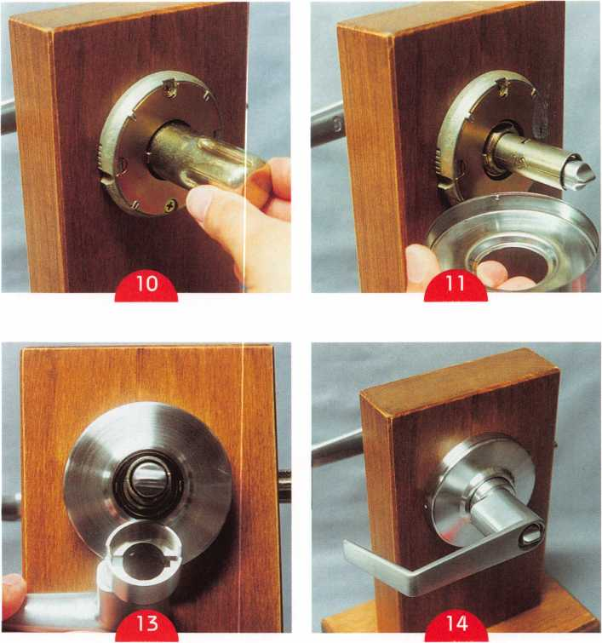
spring, to help return the lever handle to the neutral position and minimize the likelihood of sagging.
The castlenut is about to be placed on the threads of the chassis in photo 8. A special tool (or wrench) is needed to tighten it. A ratcheting sound can be heard as the castlenut is almost fully tightened. The castlenut should be tightened firmly, as in photo 9- Then the mounting screws can be inserted and tightened. With the screws tightened in photo 10, the castlenut should be re-tightened with the installation tool (wrench).
Dimples on the inside circumference of the rose should be aligned with mating grooves in the spring cage. One each of the dimples and grooves can be seen in the view shown by photo 11. Just above the groove in the spring cage are five small notches. The dimples of the rose fit into the grooves of the spring cage. After pressing the rose inward over the spring cage, the rose is rotated
slightly. The dimples on the inside of the rose grab onto the notches of the spring cage and hold it tightly, so the rose will hold securely in place as in photo 12. A plastic insert interconnects the inside lever handle and the driver piece in photo 13. The driver interacts with the spring cage, which helps return the lever handle to the neutral position and minimize sagging. The lever and driver have been assembled in photo 14.
Lock Cylinder Servicing.
With the lock fully assembled, photo 15 shows the outside lever handle with the keyed cylinder inside of it. Because the keyway points side to side, this style lever handle lockset is not handed. The keyway will point sideways on either a left or right handed door. The bottom of the keyway always points to the opening side of the door. Lock cylinder servicing is not much different for this key-in-lever lockset than a standard Schlage key-in-knob lockset. The key is used
Keynotes
January 1999
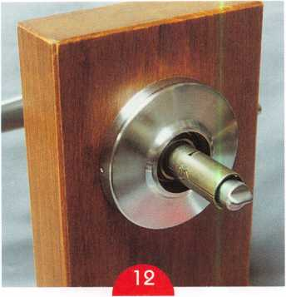
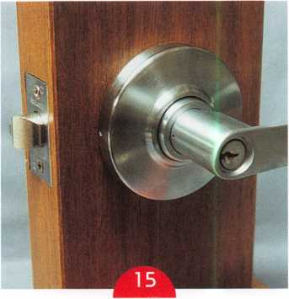
to rotate the cylinder plug in photo 16, while the poke tool is used to depress the spring loaded retainer through the access hole in the neck of the lever handle. When the lever handle is removed, in photo 17, the back of the lock cylinder can be seen inside the lever handle. A white plastic insert can be seen still engaged with the driver piece. The driver fits within the opening of the rose.
This connects the motion of the lever handle to the spring cage and helps to minimize lever sagging.
Of special note is the orientation of the tailpiece. On knobsets, the tailpiece is horizontal in relation to the keyway. On leversets, the tailpiece is vertical with the keyway.
Door Thickness Adjustment.
The AL-series lockset appears to be normally configured for a standard 1 3/4 inch thick door. If a different door thickness is required, it can be adjusted before installing it into the door. First, the keyed (outside)

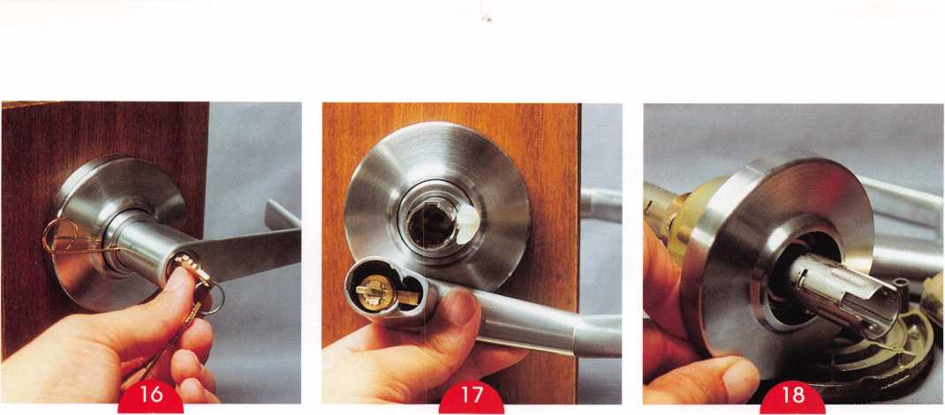
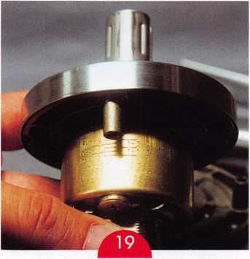
lever handle must be removed, as described previously. Then, the driver piece, behind the lever handle, should also be removed. With both parts removed in photo 18, the castlenut on the outside end of the chassis is now accessible. This castlenut should not be removed, but it can be tightened or loosened (as necessary) to move the outer assembly in or out. There are etched lines visible on the chassis, shown in photo 19, to indicate the door thickness settings. The screw post should line up with the desired door thickness setting.
After the thickness setting is adjusted, the handle can be reattached. Remember to reinstall the driver, plastic insert and lever handle, before installing the lockset on a door. Schlage AL-series lever handle locksets should be available from your current source of Schlage locks and hardware products.

L5
#704500
Deluxe Kit #704520
STRATTEC PASS-Key Interrogator.
Since 1986, STRATTEC's PASS-Key security system has led the way for a new generation of high-security automotive locks. Integrating mechanical components with electronic features, this system reduced thefts by 45% the first year it was available. Now there are about 10 million PASS-Key equipped vehicles on the road. This next-generation Interrogator makes the job of servicing them a whole lot easier. With it, the locksmith can cut duplicate keys, or generate new keys. The Interrogator reads the resistor value of the PASS-Key blank and digitally displays the results. It also includes a four-minute timer, simplifying the interrogation process.
STRATTEC
For more information, please call
your STRATTEC authorized wholesale lock distributor
January 1999
Keynotes
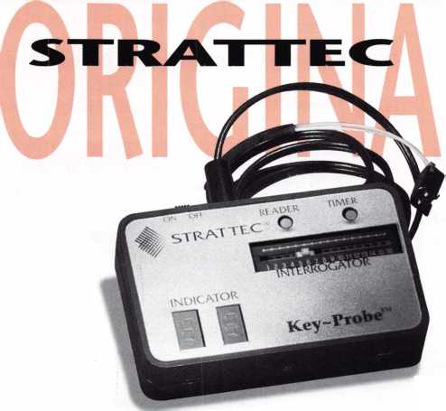

Chart 1
Number  Value | Bottom  Pin | Top  Pin |  | Key  Depth
□ | . 1 1 □ | - | 5
1 | . 1 22 | - | .3 1 B
2 | .135 | .□25 | .305
3 | . 1 47 | .□37 | .293
4 | . 1 60 | .□5D | .2SD
5 | . 1 72 | .□62 | .268
6 | . 1 B 5 | .□75 | .255
7 | . 1 97 | .□B7 | .243
B | .2 1 □ | . 1 □□ | .230
9 | .222 | .112 | .2 1 B
1 □ | - | . 1 25 | . 2 □ 5
1 1 | - | . 1 37
1 2 | - | . 1 5D
1 3 | - | . 1 62
1 4 | - | . 1 75
1 5 | - | .1 B7
1 6 | - | .200
1 7 | - | .2 1 2
1 B | - | .225
1 9 | — | .237
This month, we will continue our discussion on the Best A2 IC system by showing you how to figure out the correct pinning after selecting the control key as well as methods for removing an I core when there is no control key.
Using the charts from last month, we will now pin up a core for the first change key, 6 9 4 5 8 3. Here is how the pinning would be:
MK =69 4 5 6 1
CK = 69458 3
BP = 6 9 4 5 6 1
MP = - - - - 2 2
Now that we know the bottom and master pins, the next thing we need to do is determine the control pins. To do that all we have to do is take the control key bitting 843716 and subtract each depth from 13. This will give us the control pins:
13 | 13 | 13 | 13 | 13 | 13
S | 4 | 3 | 7 | 1 | 6
5 | 9 | ID | 6 | 12 | 7
We have now determined our bottom pins (BP), master pins (MP) and control pins (CP). All we have left to determine is the driver pins (DP). Here is what we have so far:
BP | = 6 | 9 | 4 | 5 | 6 | 1
MP | = - |  |  |  | 2 | 2
CP | = 5 | 9 | ID | 6 | 12 | 7
 | 11 | IB | 14 11 |  | 2D | !□
We subtract each of these totals from 23 to determine our driver pins.
23  1 1 | 23 23 23 23  IB 14 11 2D | 23  ID
12 | 5 9 12 3 | 13
Here’s how all of the pins in the core will be:
BP | = 6 9 4 5 6 | 1
MP | = - - - - 2 | 2
CP | = 5 9 1 □ 6 1 2 | 7
DP | = 12 5 9 12 3 | 13
Totals | = 23 23 23 23 23 | 23
It really | is that simple! At least for a two
level system. By using the pinning chart, you will not have to rely on memory for how each of these were determined. Just follow the directions on the pinning chart to fill in the data. The completed pinning chart will give you a good record of keying done, when it was done, what it was done for and who did it.
To work within an existing system you would need to know all of the original bittings, which bittings have been used and the control key bitting. When the original bitting list is not available, progressing out possible change keys for an existing system is as simple as filling in the bittings for existing keys and then progressing out the system. Eliminate all the progressions that have been used to determine bittings that can be used for expansion.
The following illustration shows an interchangeable core (IC) pinned to a change key
< Keynotes
January 1999
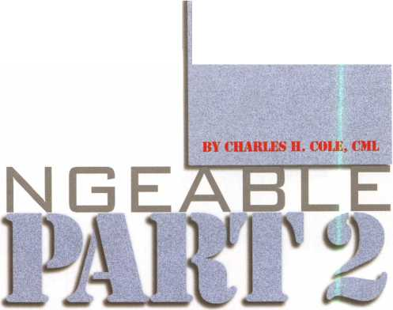

(CK) with cuts of 694583, a master key (MK) with cuts of 694561 and a control (CC) with cuts of 843716
The illustration below shows a seven pin Arrow Lock Company Core, pinned to a six pin key. Because the cuts are measured from the tip, the chamber to the bow is left empty. It should be capped off, but without any pins or springs.
chamber cap
spring
#13 driver pin
#7 control pin
#2 master pin
#1 bottom pin
The arrow points to the locking lug that retains the core in the lock housing. The control key retracts the lug so that it is flush with the core for installation or removal.
needs to be removed and any number of other factors. First, lets see how the core could be removed without drilling. To do that the core would have to be picked to the control shear line. That can be done by putting pressure on the locking lug rather than by using a tension wrench. This can be done by pressing a piece of stiff wire against the locking lug. With the core in a housing you will have to drill a small hole where the wire can be inserted. This requires exact measurement for where to drill the hole. Here are some tips for doing that, using the following illustration as a reference.
Locking Lug
- pin = 9/16"
- pin =
The illustration at
right shows a typical
IC key. This one is
from Jet Hardware
Manufacturing
Corporation for an
Arrow keyway.
DUPLICATION
PROHIBITED
NICKEL
SILVER
ONLY
This is the tip stop from which all of the cuts are measured.
REMOVING CORES WHEN THERE IS NO CONTROL KEY
One of the most common problems locksmiths encounter with ICs is how to remove an IC when they do not have a control key. This can be done in several ways, some of which we will explain here. Which way you should use depends on the type of housing the IC is in and other factors, such as how many cores are in the system, does a control key need to be made for others in the system, is this an isolated core that only
Where you drill depends on whether the core is a 6 pin or a 7 pin. You determine this by inserting a key into the core and measuring how far the key goes in. Insert a key and mark a line on the key against the face of the core. Measure the line from the tip stop on the key. The measurement will be one inch for a six pin core and one and three- sixteenths for a seven pin core. Knowing what size core you have will determine how far back from the face the locking lug is.
Dimension A, as depicted in the illustration, is one half inch for both a six pin and seven pin core. The lengths of the locking lugs is different, however. The locking lug is nine- sixteenths inch long on a six pin core and eleven-sixteenths long on a seven pin core. You should add one half of the length of the lug, for whichever size core you have, to dimension A to determine your drill point. This will put you right in the middle of the lug. Drill a hole just large enough for the wire to go through, being careful to drill only to the lug and not through it. Apply pressure against the lug with the wire and rake or pick the pins to pick for the control shear line.
To remove and measure the driver pins, I have found that it is best to carefully file the
top of the core over each chamber. This makes removing the individual chamber caps easier and makes it easier to keep the pins from getting mixed up.
Lab has made and patented a really neat device for dumping the pins and keeping them in exact order. They had a model of it at the ALOA convention in Nashville but it will not be in production until some time in 1999- Locksmiths who work with interchangeable cores will find this to be a very valuable tool.
If you have a situation where all you need to do is remove the core without regard to keeping or decoding it, perhaps to just remove it and replace it with a new one, the quickest and easiest way to remove the core is probably to drill it. When drilling a core you have to drill at the right place, drill straight and not drill too deep.
The drill point on a BEST core is right between the E and the S. On Arrow and other brands the drill point 3/16 inches above the plug, directly in line with the keyway. Before drilling you need to know whether the core is a 6 pin or 7 pin, however. You can use the method with measuring the key, as previously described, to do that. You must be careful to drill in a straight line so that you do not damage the prongs on the throw member that are inserted into the core.
You must also be careful not to drill past the last pin in the core because to do so could damage the housing that the core is in. The distance to drill for a six pin core is exactly one inch. For a seven pin core the distance to drill is one and three sixteenths inches. Use a 3/16 inch drill bit. Clear out the debris in the hole with a hook pick or something similar then use a screw driver to turn the plug and retract the locking lug. It may sometimes be necessary to turn the plug several times to get the lug retracted.
This article gives you the basics for the A2 interchangeable core system. By no means does it cover all there is to know about these cores. You have to also remember that ICs from other manufacturers, such as Yale, Corbin, Medeco, Kaba, Schlage and others will be completely different these A2 type cores.
January 1999
Keynotes L.
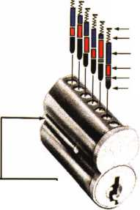
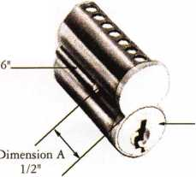
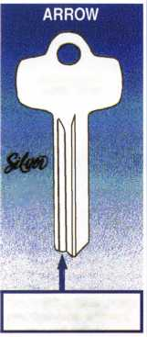

A few months ago David Lowell, ALOA’s
Education and PRP Manager, contacted me
about putting on an ACE class for the
Louisiana- Mississippi Locksmith Associa-
tion. “This ones a little
different,” he warned me. Lou-
Miss education chairman Tommy
Hunt wanted an access control
class where the students would
actually go out and install a
system. He envisioned a two-day
seminar, with one day of
classroom instruction followed
by one day of actual field
experience.
I was intrigued by this
concept and agreed to put
something together for the 30th
anniversary Lou-Miss convention
in Jackson on September 24th
and 25th.
I have had one previous
experience with combining a class with a
field exercise. At the 1996 ALOA convention
in New Orleans my assistant and I took 15
students to the IDN-Acme warehouse in
Metairie and installed a three-camera CCTV system. Actually handling the equipment and seeing how it goes together certainly adds to the learning experience. In addition,
I was impressed with how much confidence the students gained by being part of a successful installation.
The most difficult part of incorporating a
field experience into a seminar is finding a
suitable “laboratory.” New Orleans had been
relatively easy. I work for IDN-Acme and I
was more or less familiar with the headquar-
ters facility. Also, the class was
held on a Sunday, so we could
work without disrupting normal
business activities. The Jackson
installation had to be on a Friday
and I would have to find a
willing third party with a
suitable building. In exchange
for letting us experiment with
their doors, I could offer the
building owner a free access
control system.
It occurred to me that we
might find a worthy charitable
organization that would benefit
from increased security. I called
the local office of the United
Way and explained what I had to
offer. They sent a memo to several of their
members explaining our plan and I was
contacted by two groups, the Catholic
Charities and the Urban League. Eventually
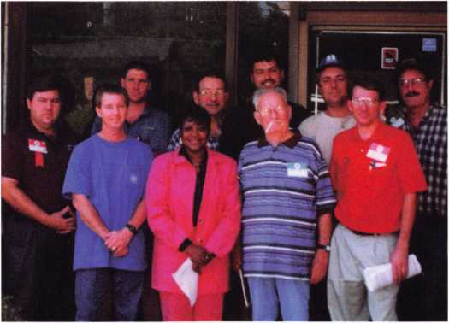
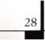
Keynotes
January 1999

Catholic Charities decided that none of their facilities would be a good candidate for the system, but Ms. Beneta Burt of the Jackson Urban League was more than willing to work with us. The Urban League is a nonprofit organization that provides a variety of services for underprivileged people including job training, housing assistance and child care programs.
I asked George Thrash, a Jackson-area locksmith and Lou-Miss board member, to visit the proposed site and check it out for me. With George’s help I was able to design a two-door access control system that would meet Ms. Burt’s needs.
The next part was easy. I decided which products I wanted to use and asked the manufacturers to donate them. Both International Electronics (IEI) and Security Door Controls (SDC) were happy to help. IDN- Acme also came through with wire and several other items.
I asked SDC for two 1571V mag locks and two of the new MSB5 50-2 switch exit bars. The MSB550-2 is a non-latching, mechanical switch bar featuring two SPDT micro switches for double-break egress control. The 1571V is a 1200-pound electromagnetic lock with the unique “no-epoxy” appearance.
IEI donated two of their Secured Series mullion-style keypads and two of the brand new Hub-Plus Kits. The Hub-Plus Kit includes a one amp power supply, a hub control and a central terminal strip for connection of all the system components, all contained in a locking enclosure. They also threw in a copy of the “HubMan” for “Windows” software for computer management of the Secured Series network. Audit trail, time zones and user databases are easily accessed in the HubMan program.
The Urban League offices have two sets of double aluminum-framed doors. The secondary doors were equipped with flush bolts and were only opened when furniture had to be moved in or out. The back doors were being locked at night with a chain and padlock. Our system would improve the physical security of the entrances and provide the employees and volunteers with greater control over visitors entering the facility. The League is located in the community it serves, a neighborhood with a reputation of being a high-crime area. The added security was greatly appreciated.
I admit I was suffering from some nervous anxiety about this experiment. We only had one chance to get this system installed and working. Experienced installers know how many little things can go wrong. Would we reach an impasse because a necessary part or tool was missing? Would the building have any “surprises” that might make it difficult or impossible to run our wires according to plan? Would all of the components we installed work correctly?
I am happy to report that we accomplished our mission. The 10 students and I arrived at the offices by 8:30 A.M. and we left the system installed, programmed and operating by 2:00 pm. George Thrash joined us and brought his service van with most of the tools we needed. I brought along my “FiberFish” tools from BES Manufacturing and our wire-pulling time was cut in half. Fiberfish is a set of flexible Fiberglas rods designed to facilitate pulling wires through walls, aluminum door frames and over ceilings. We did encounter a couple of problems, but we were able to overcome them, which added to the learning experience.
I was thankful that my class included both beginners and experienced installers. The experienced guys acted as team leaders and shared their practical wisdom with the new guys. The installation was more a matter of sharing information than a “class” and we all learned some new tricks that day.
Ms. Burt and the Urban League really appreciated the gift and we were grateful to have a place to work. It was a win-win situation.
After the job was finished we sent a press release to the local papers describing our project. The League is planning to highlight us in their next newsletter and at their quarterly board meeting. In this way lots of local people will hear about how a group of locksmiths came to Jackson and gave something back to the community. They will also be more likely to think of calling a locksmith when they need access control.
You cannot buy publicity like that.
All things considered, the access control seminar in Jackson Mississippi was a success. We managed to combine education, public relations, service to others and enjoyable fellowship and isn’t that what our associations are all about?
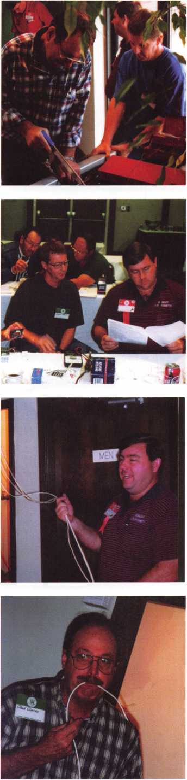
January 1999 Keynotes

THE
The name ABUS is not anyone’s name, but is a German acronym. A -August, B-Bremicker; U-und (and), S-Sonne (Sons): August Bremicker and Sons.
The company was founded in Germany by August Bremicker in 1924. Six years later, in 1930, this small padlock manufacturing company had only 20 employees. There are now more than 2,000 people working for ABUS plants in Germany, Italy, Hong Kong and the Industrial Free Zone of China. Their padlocks vary in shape, size and function to fit many different applications. While many look like most typical padlocks, the Diskus, with its disc shape and rotating circular shaped shackle, stands out. Although now imitated, the first of its kind was introduced in 1949.
The standard Diskus padlock is 70 millimeters in diameter. Translated to inch measurements, it is about 2 3/4 inches wide. Photo 1 shows the standard 70 millimeter size on the right.
The “Baby Diskus” was introduced in 1991, at 60 millimeters (2 3/8 inches). One of that size is on the left in photo 1. With slightly different lock and cylinder designs for some, there are a total of four different sizes of Diskus padlocks. In addition to the 60 and 70 millimeter sizes, there are the 80 mm (3 1/4 inches) and 90 mm (3 5/8 inches). The two padlocks in photo 1 are pin tumbler style.
Standard Diskus pin tumbler padlocks are considered the 24 series. The small padlock, therefore is model 24/60. The lock on the right is a new rekeyable Diskus. A non-rekeyable version of the larger padlock would have been a model 24/70. Except for the new rekeyable Diskus padlocks (to be explained later), most Diskus locks are not designed to be serviced or rekeyed. The 24 series padlocks are available in three sizes: 60 mm, 70 mm and 90 mm.
The standard Diskus lock body is made of stainless steel and uses case hardened or stainless steel shackles. There is a lower cost version of the standard 70 mm size Diskus called the “Buffo.”
The inside of this lock is steel rather than stainless steel, which reduces the cost. It is otherwise identical in appearance to the standard 24/70 Diskus. The Buffo is designated the 28 series, so the equivalent Buffo lock would be model 28/70. The Buffo is not available in smaller or larger sizes.
Keynotes
<
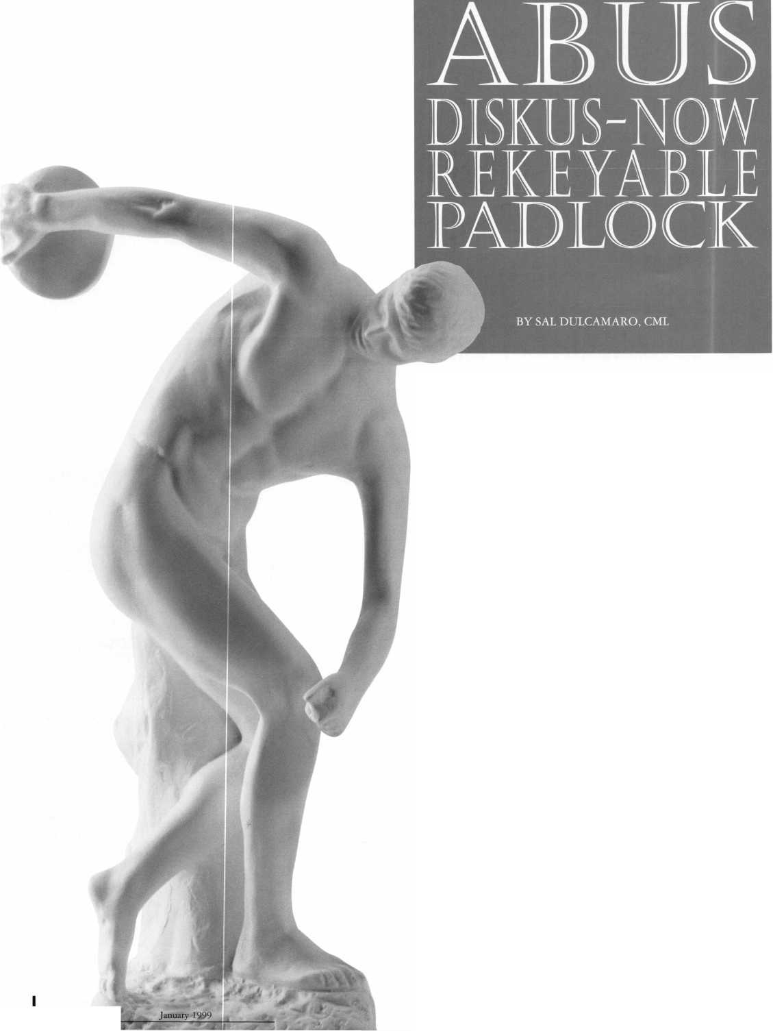
Photo 2 shows a model 20/70 Diskus. The 20 series line doesn’t use a pin tumbler cylinder. Instead it uses a six disc (rotating disc) high security cylinder. ABUS uses the same type of cylinder in a number of other padlock lines. It is referred to as the ABUS Plus high security cylinder.
The Plus cylinders are rekeyable in some ABUS padlocks, but are not currently rekeyable in the Diskus line. The keys to the right of the padlock have angled cuts and require special machinery to cut them. The 20 series Diskus padlocks come in two sizes: 70 mm and 80 mm. The one shown has the standard 70 mm body size.
ABUS makes a special hardened hasp, shown in photo 3, which is specifically designed for use with the Diskus padlock. It is specially shaped to completely cover the closed shackle of a Diskus padlock and designed to reduce vulnerability to bolt cutters. It is intended for use with 70 or 80 millimeter Diskus padlocks only (regardless of cylinder type). The smaller 60 mm or larger 90 mm locks should not be used with this hasp.
HOW THE PLUS CYLINDER WORKS
The Plus cylinder and keys are similar to the Abloy lock cylinder and keys in operation. For those unfamiliar, it is something like a sidebar lock with discs that rotate rather than move up and down. Photo 4 shows the model 20/70 Diskus with the key inserted and rotated slightly more than a quarter turn. It is apparent that the shackle has yet to move.
A rotating disc tumbler lock is somewhat different in concept compared to most other types of lock cylinders. Whereas rotation of the key usually indicates rotation of the plug and actuating mechanism for most cylinders, it doesn’t for a rotating disc tumbler lock. The variously angled cuts on the key do not even entirely engage all the tumblers until nearly a one quarter rotation.
The tumblers are contained within a sleeve. As the key turns, it gradually picks up each of the tumblers until all are rotating together. The deeper the angle cut into the key, the longer it will take for the cut surface to engage the inner surface of its mating tumbler. Like a mechanical dial type combination lock, there are gates cut into the outer circumference of each tumbler. If the key has the proper cuts, when rotation reaches slightly more than a quarter turn, the gates of the tumblers will be positioned underneath a locking bar (or sidebar) that extends from the sleeve to the lock cylinder shell. With the gates lined up, continued rotation forces the locking bar completely into the sleeve and allows the sleeve to then rotate.
Continued rotation of the key will start to actuate the mechanism. It is movement (rotation) of the sleeve and not the key alone that causes the lock to unlock. Photo 5 shows the key having rotated nearly a half turn and the shackle is only just beginning to move. Continued rotation of the key (and sleeve), as in photo 6, will completely open the shackle. Photo 7 is a closeup of the ABUS Plus keys with angled cuts in each tumbler position. If an incorrect key were used in the lock, the key would still rotate one quarter turn. If the tumbler gates don’t all line up with the locking bar, the key won’t rotate further. A partially inserted (but correct) key will do the same when the angled cuts engage the wrong tumblers.
THE REKEYABLE DISKUS
Photo 8 shows a rekeyable Diskus model 24RK/70 padlock, keys and a cylinder removal tool. This Diskus is the same size as the standard non-rekeyable model 24/70. Unlike the Plus cylinder padlocks, the pin tumbler cylinder immediately engages the lock
January 1999
Keynotes
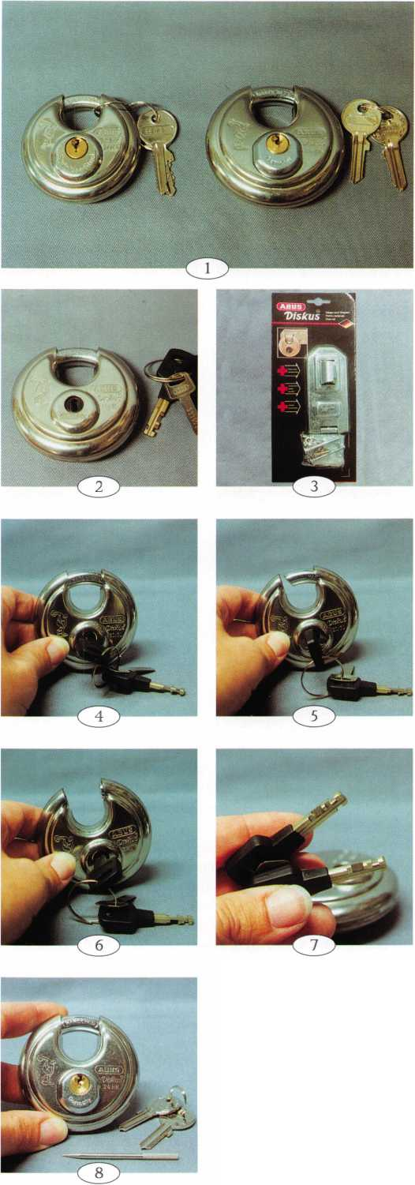

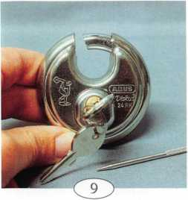
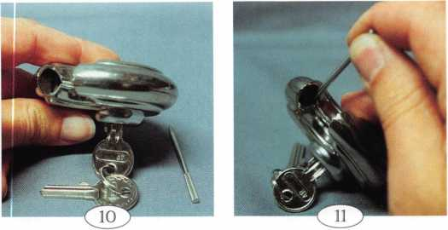
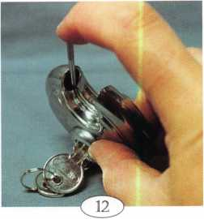
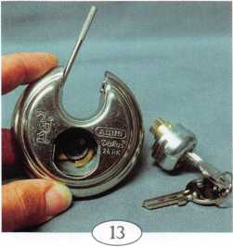

mechanism and moves the shackle, as in photo 9- The circular shackle rotates in a way that when the lock is fully opened the shackle is completely concealed within the body of the padlock.
Looking into the shackle opening in photo 10, one end of the (concealed) shackle can be seen stopped against some kind of pin which prevents over-rotation.
The cylinder removal tool is being positioned for insertion in photo 11. The tool, which looks like a thick oversized needle, will be pushed inward just below the pin that stopped the shackle s movement. The tool is being inserted in photo 12. When it is pushed far enough, a retainer will disengage from the housing that surrounds the lock cylinder, so that it can be removed. Photo 13 shows the open cavity where the cylinder used to be. The cylinder removal tool is still engaged, keeping the retainer from coming back out. Removing the tool, as in photo 14, allows the retainer to pop back out. The extended retainer would normally catch into the slot in the cylinder housing.
Photo 15 shows a service kit for the ABUS rekeyable Diskus padlocks. Included in the kit are tumblers, tumbler springs, a cylinder removal tool, a plug follower, extra C-clips, depth keys and a key gage. To service the lock cylinder, the C-clip must first be removed. The clip is partially off in photo 16. Once the clip is removed, the operating key should be inserted and the plug should
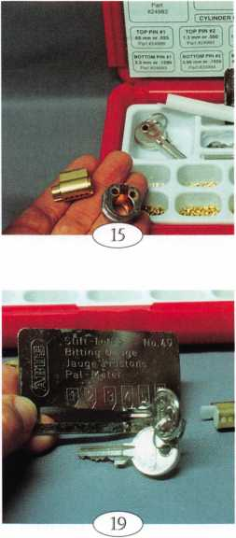
be slightly rotated. The plug follower matches up against the back end of the plug in photo 17. This follower is designed specifically for the size and shape of this cylinder plug.
Photo 18 illustrates why the plug should be slightly rotated first, before plug removal. The last (fifth) pin chamber is empty. Although this lock cylinder was drilled for five pin chambers, it only has four chambers coded. If the plug would have been followed out straight, the top pin in the fourth chamber would have dropped into the empty fifth chamber of the plug. The plug would have been trapped, and unnecessary work and grief would follow to correct the situation. Rotating the plug would make sure that no spring loaded top pins would be directly in line with empty plug chambers.
The ABUS key gage is shown in photo 19- If you needed to code a cylinder to a specific key, you could use the gage to decode the cuts. Then the service kit would provide whatever pins you might need to accomplish that. The depth key set is shown in photo 20. There are five keys in the set for depths 1 through 5.
ABUS padlocks are not available through some locksmith supply companies. In other cases, only a small part of the product line will be available through your supplier. If you are unable to find the ABUS brand padlocks that you are looking for, contact: ABUS Lock, USA, 3555 Holly Lane North, Plymouth, MN 55447-0507. Phone: 800/352-2287.
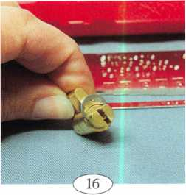
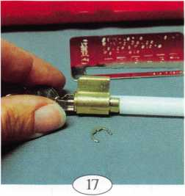
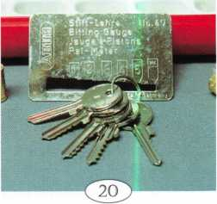
321 Keynotes
January 1999
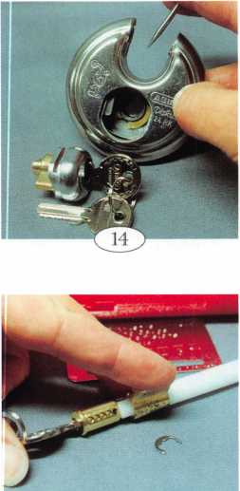
/
By Claire L. Cohen, CML
The Proficiency Registration Program (PRP) has come a long way, since 1985 when the first test was given at an ALOA Convention. Over 6,000 locksmiths throughout the world have taken the initial PRP step.
Early years of PRP history included administration and coordination by ALOA board members. This process has been streamlined and moved to the ALOA office in Dallas, Texas. David Lowell, CML is now a full-time ALOA staff member, serving as the Director of PRP and Education. A full-time PRP/Education assistant, Ashley Spencer, schedules PRP sittings, processes applications and maintains the PRP database.
Costs of administering the test have been lowered. Proctors all over the United States are called upon when a test is in their geographical area. This has substantially lowered travel expenses incurred in prior years.
The PRP is no longer given solely at the ALOA convention (although the greatest number of people takes the test at the convention). The PRP is held 30 to 35 times a year throughout the U.S. The European Locksmith Federation and the Master Locksmith Association of Great Britain have also hosted PRP evaluations.
Tokyo, Japan will be the site of a PRP in November 1998 with 51 locksmiths registered. This will be an oral examination, translated into Japanese. Overhead projection will be used for drawings/graphics.
In earlier years, ALOA board members primarily wrote PRP test questions. The individual tests have been revised and rewritten many times. Some of the materials have been deemed out of date. Some tests required too much memorization. Actual field experience may not have been thoroughly covered. To update and revise these tests, the expertise of industry professionals has been called upon.
An experimental format was tested at the
ALOA convention in Nashville, Tenn. this past summer. Four classes (Domestic Auto, Foreign Auto, Life & Safety Codes and Motorcycle Locks) were taught. The Motorcycle class was developed with particular emphasis on the PRP elective test. At the end of the classes, a PRP evaluation was administered for each elective category. Passing their elective category would bring students one step closer to earning their certification.
Mixed results from these classes will lead to future revision of the classes and those sections of the PRP. A new and more expanded list of classes, followed by a PRP test, are being planned for the next convention. If a student wishes to take the PRP elective at the end of a class, a lab fee or surcharge will be required.
Another change made is that there is no limit to the number of electives that can be passed before the Mandatory portion of the PRP is passed. This means that students may take as many classes as they wish, followed by a PRP elective test. All tests passed are cumulative after passing the Mandatory portion, locksmiths may be well on their way to the next level of certification!
As of October 1998, the Mandatory test contains 250 questions. There are 26 Elective categories. Each Elective category contains between 25—30 questions. Passing rate on the Mandatory test is good, according to David Lowell, CML, Director of the PRP. Passing rate is higher on some electives, which requires only a class or two to cover most of the material on an Elective test.
Each week locksmiths relatively new to the industry register for the PRP, attempting to gain the first level of certification-CRL. Currently (10/98), there are:
- 2,461 Registered Locksmiths/
Certified Registered Locksmiths
- 607 Certified Professional Locksmiths
- 674 Certified Master Locksmiths
- 2,385 who are in the PRP program,
but have not yet attained certification.
Closed Circuit TV a new elective is scheduled to be introduced the first part of 1999- Also on the drawing board— Padlocks. Again, industry experts are working on compiling test questions.
PRP Prep Courses continue to be well received at the ALOA Convention. The prep course, an extension of local chapter study sessions, is popular as a part of the educational program at trade shows and local associations’ classes.
The Resource Guide (available from ALOA) will contain a new glossary developed by the LIST Council. The new glossary will incorporate 1,236 additional terms that will be combined with the previous glossary (which contained primarily masterkeying terms). This will expand the entire spectrum of locksmith terminology.
Future plans include identification of places to obtain PRP-related training. This will include developing additional classes. Additionally, 30 to 35 booklets will be published comprised of articles from past issues of Keynotes magazine. These articles directly relate to PRP test areas. This will, hopefully, resolve the problem of new members having difficulty obtaining old copies of Keynotes for PRP related articles. The intent is to incorporate these booklets for sale into the ALOA Bookstore.
Associations sponsoring a PRP usually average 18 to 20 participants. Occasionally, PRP evaluations are given with as few as eight to 10 candidates. There is no minimum number due to decreased administrative expenses. Scheduling PRP evaluations is often coordinated with ACE classes. To obtain an application and a list of PRP test sites, call Ashley or David at ALOA or visit their web site at www.aloa.org.
With all of the changes, isn’t it time you applied to take the next PRP?
January 1999 Keynotes | 33

The most expensive start up cost of your business will be your mobile shop van or truck. As an independent locksmith, this service vehicle projects your image to the community you will be serving.
With that, let’s consider the importance this vehicle plays in your overall success. The first impression you’ll make to your customer is when he sees you drive up in your service vehicle. If your shop van (or truck) is dirty, rusty or damaged you’re presenting a negative image to your customer.
Would you have someone working in your home or business looking like that? The immediate answer would be “no.” If it is clean and professional looking you’ll instill a sense of immediate confidence in your customer and reinforce your skills and abilities as a locksmith.
One of the most important business decisions you will make in starting up your company and presenting an image that will benefit you is choosing the right kind of vehicle for the area where you’ll be working. The first thing to consider is always remembering the location and make-up of the community you plan on working in. I live on Nantucket Island, a small island 30 miles at sea off of the southern coast of Massachusetts. Its distance is three and one half miles wide and 14 miles long. Historically, it’s the 18th century “Whaling Capital” of the world with narrow cobblestone streets. Parking in both residential and commercial areas is limited, and we do not have one stop light on the island.
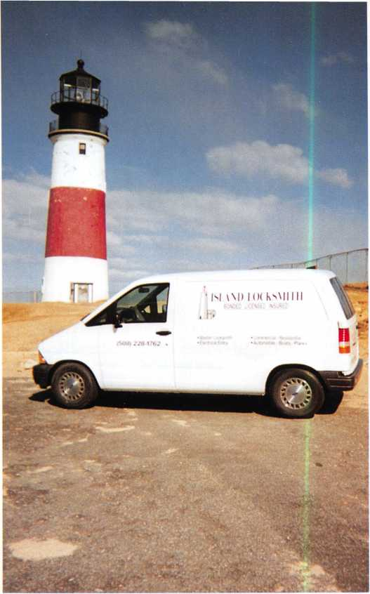
I purchased a 1994 Ford Aerostar the first year that I started my business. It is standard size and small enough for driving through my small town streets, yet large enough to provide me a comfortable working area, for my tools and stock items.
If you live in a large city or medium size rural town you might consider any size van or truck. The type of vehicle you drive tells a lot about you to your customers as well. There are a number of different types of service vans and trucks available for purchasing or leasing on the market today. The color that you select for this vehicle is also an important.decision to make.
Eight out of 10 service vehicles on the road today are white in color. Several other colors are available, but white is the most predominant. Needless to say, my shop van is white. If you like a different color that best suits your needs then by all means consider that color.
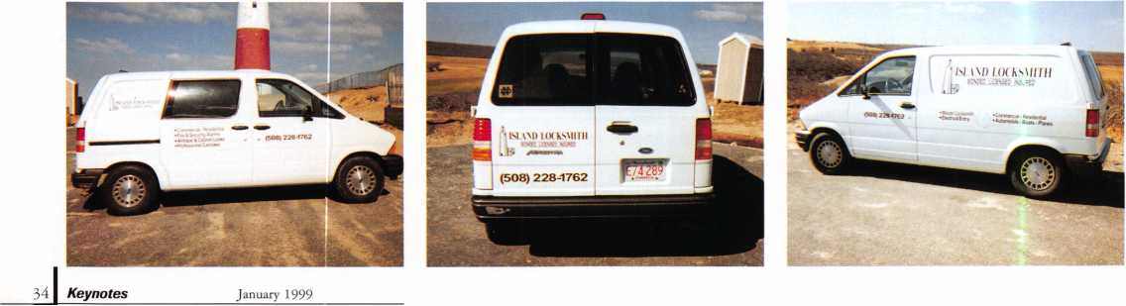

Gray, light blue and soft browns are excellent choices also. The reason for picking the right color for your shop van or truck leads us into the color(s) of the letters and words that constitute the advertising you’re going to place on it.
Look around the corner block near your home or business and sooner or later you’ll see that Post Office Mail Truck, ADT Security Alarm Systems Truck, Wells Fargo or the Brink’s Security Van (you’ll find them often published in trade magazines). Notice the color of the van and the color of the letters and words on the service vehicle.
Large commercial companies use the same vehicle, same identifiable colors, same logos, and the same words on their service fleet. They do it for a number of reasons. Some do so for uniformity and name recognition; it promotes their services and business. Owning one shop van (to start) doesn’t allow you much room to make any mistakes. Choose the best colors, and the right size letters, and words to place on your shop van,
When applying lettering to your vehicle consider two things—
#1 the size and color of the letters; and #2 the readability of the information in a short period of time. There is a big difference between the large billboard messages you see on the highway, and those small billboard signs you see in your hometown.
Your shop van is a moving billboard that everyone in your community will see daily. What they see on it, how you display your abilities and the products you are selling will send an image that will only help your business grow if it is done with some thought and common sense.
The size of your letters and the words is very important. The standard letter size most noticeable on the streets and highways today start at three inches. Larger words, at six inches or higher, projects clear and easily identifiable words that can be seen and read at distances up to 25 feet. The larger the letters are and the variation of lettering sizes will increase the distance they can be seen. The average distance a person will view and read any written letter or words on a stationary or moving object is between 12 to 25 feet.
Give some serious thought on what size lettering should be on your vehicle. When you do place lettering on your shop van, chose the right color(s).
Try not to use more then two colors. Why only two colors? Well, how many times have you seen a national chain service vehicle with more than two colors on it? Probably, very few (remember the larger security companies). Multi-colored vehicles (three or more colors) and different size lettering remind me of the local ice cream truck we see in the neighborhood on Saturday mornings. I would recommend the color black for the letters or a combination of black and red lettering on a white background. Remember 80 percent of most service vehicles on the road today are white trucks with black letters and words. Red is a color we are conditioned to understand at an early age. A combination of both of these colors will attract any person’s attention and create the right effect, if they can be seen legibly from a distance.
Another factor to consider when deciding what to have on your van is what I’ll refer to as “the three second rush.” How many times have you passed a service vehicle on the road, driving 35 to 55 miles
an hour in heavy traffic and immediately tried to write down the phone number? The human eye takes exactly three seconds to focus on a stationary object; it may take longer on a moving object depending upon speed and distance (for us older guys and gals it may take us a little longer still).
For those of you who have been in the military service, remember the “three second rush” in basic training? After seeing the telephone number, try to find something to write it down on, and then finding that piece of paper (in my case a match book cover), you immediately look up only to see that the service van has faded in the distance. Think of what a potential customer must be thinking when your letters and words are too small, different sizes and colors, and he’s having difficulty trying to find a pen and paper to write that company name and telephone number down on.
It’s to your advantage to take a few days to look at other service vehicles in your area. Remember the good ones and the best designs. Then, take the best ideas and apply them to your vehicle. Speaking of applying a certain type of lettering material to your shop van, you should give that some thought as well.
Next month, we’ll continue our look at how to effectively utilize your shop van and discuss word and logo usage among other helpful tips.

Training

Certification
For a FREE VATSmith information packet and
locations of BWD Certified VATS Centers
Cal!
„ 800-647 4926
See us at www.alllock.com
January 1999 Keynotes
35
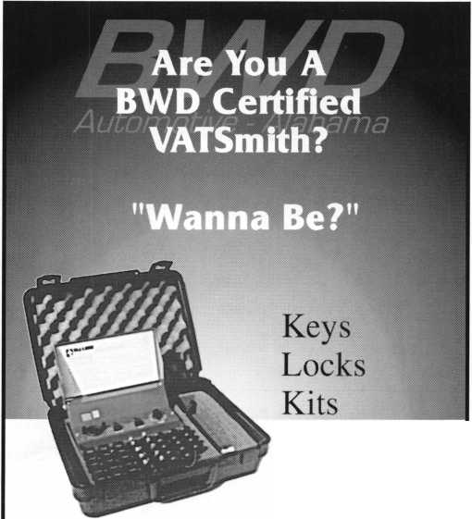

Associate

Members
Manufacturers | Arrow Lock Company  10300 Foster Avenue  Brooklyn, NY 11236 (718) 257-4700; FAX (718) 649-9097
 | • •••
A & B Safe Corp.  171 S. Delsea Dr.  Glassboro, NJ 08028 (800) 253-1267; FAX (609) 863-1208 | Auto Security Products (A. S. P.)  P.0. Box 10  Redmond, WA 98073-0010 (425) 556-1900; FAX (425) 558-1205
• • • • | • ®
ASSA Inc.  10300 Foster Ave.  Brooklyn, NY 11236 (800) 235-7482; FAX (718) 257-2772 | BWD Automotive  900 Ravenwood Dr.  Selma, AL 36701  (334) 874-9001; FAX (334) 874-6011
• | • e
Abus Lock Company  3555 Holly Lane North  Plymouth, MN 55447-0507 (800) 352-2287; FAX (612) 509-9939 | Chicago Lock Company  10100 88th Ave.  Pleasant Prairie, Wl 53158-0069 (800) 445-3204; FAX (414) 947-7178
• | ®
Adams Rite Manufacturing Co.  P.0. Box 1301  LaPuente.CA 91749-1301 (562) 699-0511; FAX (562) 699-5094 | Corbin Russwin Architectural Hardware  P.0. Box 25288  Charlotte, NC 28229 (800) 543-3658; FAX (800) 447-6714
^ (0 (Q | • • • •
Adesco Safe Manufacturing Co.  web: www.adesco.com email: sales@adesco.com (800) 821-6803; FAX (562) 408-6427 | Curtis Industries  6140 Parkland Blvd, Ste. 300  Mayfield Heights, OH 44124-4103 (800) 555-5397
• | • •
Adrian Steel Company  web: www.adesco.com email: sales@adesco.com (800) 677-2726; FAX (517) 265-5834 | DETEX  302 Detex Dr.  New Braunfels, TX 78130 (800) 729-3839; FAX (830) 620-6711
• | • • • •
Alarm Lock Systems, Inc.  345 Bayview Ave.  Amityville, NY 11701 (800) ALA-LOCK; (516) 789-3383 | Don-Jo Manufacturing, Inc.  P.O. Box 929  Sterling, MA 01564 (508)422-3377; FAX (508) 422-3467
• | ® o
Aiphone Intercom Systems  1700-130th Avenue, NE  Bellevue, WA 98005 (425) 455-0510; FAX (425) 455-0071 | Door Controls International  2362 Bishop Circle East  Dexter, Ml 48130  (800)742-3634; FAX (800) 742-0410
• • • | • • • •
American Lock Co.  3400 West Exchange Road  Crete, IL 60417-2099 (708) 534-2000; FAX (708) 534-0531 | ESP Lock Products, Inc.  375 Harvard Street  Leominster, MA 01453 (978) 537-6121; FAX (978) 534-9109
• * | m •
American Security Products (AMSEC)  11925 Pacific Ave.  Fontana, CA 92337-6963 (800) 423-1881; FAX (909)685-9685 | Folger Adam Security, Inc.  16300 W. 103rd Street  Lemont, IL 60439  (630) 739-3900; FAX (630) 739-6138
• • | ® •
Associate members of the Associated Locksmiths of America (ALOA) manufacture or distribute materials or equipment, or provide services, for the security industry. Many have donated money, services and equipment to ALOA in addition to their annual dues. Their support of ALOA projects enhances overall membership benefits and we encourage our members to patronize these firms. If you know of a potential candidate for associate membership, please contact the ALOA Sales staff at (214) 827-1701. Associate member dues are $500 per year and entitle the payor to use the ALOA logo, and selected discounts on ALOA products and services.
9 Alarms: Personal, vehicle, electronic, fire, burglar, and exit
9 Automotive: Lockout equipment, key chains/rings
9 Builders Hardware: Door closers, fumiture/decorative hardware, viewers, emergency exit devices
Books, reference guides, publications, computer software
9 CCTlf/Photo Imaging: Cameras, monitors, photo ID equipment, cables
9 Electric/Electronic Security: Card access control and readers, surveillance, electric/magnetic locks and strikes, keypads
® Lock Devices: Auto locks, cylinders, emergency exit/entrance control, locks (various types), strikes
9 Tools & Supplies: Key blanks, cutters, picks, rings/hooks, custom van/tmck supplies
Keynotes
January 1999

Fort Lock Corp.  3000 N. River Rd.  River Grove, IL 60171 (708) 456-1100; FAX (708) 456-9476 | La Gard, Inc.  3330 Kashiwa Street  Torrance, CA 90505 (310) 325-5670; FAX (310)325-5615 | Rutherford Controls Inc.  2697 International Pkwy, Bid 5 #100  Virginia Beach, VA 23452 (757) 427-1230; FAX (757) 427-9549
• ••••• | • • • | •
Grobet File Co. of America  750 Washington Ave.  Carlstadt, NJ 07072 (800) 962-7242; FAX (800) 243-2432 | Lori Lock  P.O. Box 1040  Southington, CT 06489 (860) 621-3605; FAX (203) 621-5972 | STRATTEC Security Corp.  3333 W. Good Hope Rd.  Milwaukee, Wl 53209 (414) 247-3333; FAX (414) 247-3329
• | • • | • • •
H.E.S., Inc.  2040 W. Quail Ave.  Phoenix, AZ 85027 (602) 582-4626; FAX (602) 582-4641 | Lucky Line Products  7890 Dunbrook Rd.  San Diego, CA 92126 (619) 549-6699; FAX (619) 549-0949 | Sargent & Greenleaf, Inc.  P.O. Box 930  Nicholasville, KY 40340-0930 (606) 885-9411; FAX (606) 887-2057
• • • | • | • • • •
HPC, Inc.  3999 N. 25th Avenue  Schiller Park, IL 60176 (847) 671-6280; FAX (847) 671-6343 | M.A.G. Engineering & Mfg. Inc.  15261 Transistor Lane  Huntington Beach, CA 92649 (714) 891-5100; FAX (714) 892-6845 | Schlage Lock Co.  1915 Jamboree Suite 165  Colorado Springs, CO 80920 (800) 847-1864; FAX (800) 452-0663
• • • | • • • | • •
llco Unican  400 Jeffreys Road  Rocky Mount, NC 27804 (919) 446-3321; FAX (919) 446-4702 | MARKS USA  5300 New Horizons Blvd.  Amityville, NY 11701 (516) 225-5400; FAX (516) 225-6136 | Schwab Corporation  3000 Main St.  Lafayette, IN 47903-5088 (765) 447-9470; FAX (765) 447-8278
••••••• | © | •
In Out Systems, Inc.  3650-B Matte Boulevard  Brassard, Quebec J4Y-2Z2, Canada (514) 444-5949; FAX (514) 444-2029 | MUL-T-LOCK USA, Inc.  300-1 Route 17 South Suite A  Lodi, NJ 07644  (800) 562-3511; FAX (973) 778-4007 | Securitron Magnalock Corp.  550 Vista Blvd.  Sparks, NV 89434  (800) 624-5625; FAX (702) 355-5636
• • | • • • | <0 i
Intellikey  551 S. Apolo Boulevard, Suite 204  Melbourne, Florida 32901 (800) 226-0703; FAX (407) 724-0811 | Master Lock Company  2600 North 32nd Street  Milwaukee, Wl 53211 (414) 444-2800; FAX (414) 449-3114 | Security Door Controls  3580 Willow Lane  Westlake Village, CA 91361 (805) 494-0622; FAX (800) 959-4732
 | e • | •
Jet Hardware Mfg. Co.  800 Hinsdale Street  Brooklyn, NY 11207 (718) 257-9600; FAX (718) 257-0973 | Medeco Security Locks  P.O. Box 3075  Salem, VA 24153  (540)380-5000; FAX (540) 380-5010 | Security Solutions  1640 W. Hwy. 152  Mustang, OK 73064 (405) 376-1600; FAX (405) 376-6870
• | • • • | • • •
KABA High Security Locks  P.O. Box 490  Southington, CT 06489 (860) 621-3601; FAX (860) 621-9727 | Meilink Safe Company  111 Security Parkway  New Albany, IN 47150 (800) 634-5465; FAX (800) 896-6606 | Sentry Group  900 Linden Ave.  Rochester, NY 14625-2784 (716) 381-4900; FAX (716) 381-8559
m | • | •
KEY-BAK; Div. of W. Coast Chain Mfg. Co.  1460 S. Balboa Ave.  Ontario, CA 91762 (909) 923-7800; FAX (909) 923-0024 | NKL Industries Ltd.  1111-13 Cavalier Blvd.  Chesapeake, VA 23323 (800) 528-9900; FAX (757) 485-0271 | Sully Tools Inc.  3515 Nodding Pine Ct.  Fairfax, VA 22033  (703) 689-3416; FAX (703) 787-0869
• • • • | • • • • | <0)
Knaack Manufacturing Co.  420 E. Terra Cotta Ave.  Crystal Lake, IL 60014 (800) 456-7865; FAX (815) 459-9097 | National Cabinet Lock  200 Old Mill Road, P. 0. Box 200  Mauldin, SC 29662 (864) 297-6655; FAX (864) 297-9987 | TIB Canada Ltd.  2164 Oneida Crescent  Mississauga, Ontario, Canada L5C IV6 (905) 566-9198; FAX (905) 566-9697
• | • | • • • • •
LAB Security  700 Emmett St.  Bristol, CT 06010  (800) 243-8242; FAX (203) 583-7838 | Newman Tonks  805 N Buckman St.  Shepardsville, KY 40165 (800) 826-5792; FAX (800) 777-8229 | Taymor Industries, Inc.  1586 Zephyr Ave.  Hayward, CA 94544 (800) 388-9887; FAX (800) 288-8133
• | • • | • •
LCN Closers (Division of Ingersol)  121 W. Railroad Ave.  Princeton, IL 61356 (815) 875-3311; FAX (815) 875-3222 | ROFU International Corp.  2004-B 48th Ave.; Court E  Tacoma, WA 98424 (800) 255-7638; FAX (253) 922-1728 | Trine Products Corporation  1430 Ferris Place  Bronx, NY 10461  (718) 829-4796; FAX (718) 792-9127
• | • • • | • • •
Keynotes \ 37
January 1999

Weiser Lock Company  6700 Weiser Lock Blvd.  Tucson, AZ 85746  (502) 741-6338; FAX (520) 741-6363  9 9 | DiMark International  3117 Liberator St., Unit A  Santa Maria, CA 93455 (800) 235-2435; FAX (805) 928-8034  • 9 | Hardware Agencies, Ltd.  1220 Dundas Street East  Toronto, ON M4M 1S3 (416) 462-1921; FAX (414) 462-1922  ••••••••
Yale Security Inc.  P.O. Box 25288  Charlotte, NC 28229-8010 (800) 438-1951; FAX (800) 338-0965  • III | Dire’s Lock & Key Co.  2201 Broadway  Denver, CO 80205  (303) 294-0176; FAX (303) 294-0198 | Hardware Suppliers of America  P.O. Box 2208  Winterville, NC 28590 (800) 334-5625; FAX (800) 334-5635  • 9
Zhongshan Hua Feng Lock Products  S Yongning Industrial Road, Ziaolan Zhongshan Guangdong, China  86-760 227 82 63; FAX 86-270 227 80 63  • | Direct Security Supply, Inc.  36 Lincoln Street  Boston, MA 02135 (800) 252-5757; FAX (800) 452-8600  ••••••• | IDN, Inc.  1000 S. Main, Suite 280  Grapevine, TX 76051 (817)421-5470; FAX (817) 421-5468  ••••••••••
Distributors | Doyle Lock Supply  2211 W. River Road N.  Minneapolis, MN 55411 (800) 333-6953; FAX (612) 521-0166  ••••••••••• | Intermountain Lock & Supply Co  3106 South Main Street  Salt Lake City, Utah 84115 (800) 453-5386; FAX (801) 485-7205  ••••••••••
Accredited Lock Supply Co.  P.O. Box 1442  Secaucus, NJ 07096-1442 (800) 652-2835; FAX (201) 865-5031  ^ @ ® | Dugmore & Duncan Inc.  30 Pond Park Rd.  Hingham, MA 02043 (888) 384-6673; FAX (888) 329-3846  ####### | JLM Wholesale, Inc.  3095 Mullins Ct  Oxford, Ml 48371-1643 (800) 522-2940; FAX (800) 782-1160  9 9 9
Ace Lock & Security Supply Co.  565 Rahway Ave.  Union, NJ 07083-6631 (800) ACE-LOCK; (800) ACE-FAX4 | E. L. Reinhardt Co., Inc.  3250 Fanum Road  Vadnais Heights, MN 55110 (800) 328-1311; FAX (612) 481-0166  •••••• | Jo-Van Distributors Inc.  929 Warden Ave.  Scarborough, Ontario MIL 4C6 (416) 752-7249; FAX (416) 752-3845  •••••••••••
Akron Hardware Consultants, Inc.  2579 South Arlington Road  Akron, OH 44319  (800) 321-9602; FAX (800) 328-6070  • • • | Ewert Wholesale Hardware  4709 W 120th St  Alsip II 60658  (800) 451-0200; FAX (708) 597-0881  9 9 9 • 9 | Lockmasters, Inc.  5085 Danville Road  Nicholasville KY, 40356 (606) 885-6041; FAX (606) 885-7093  9 9 9 9
American Security Distribution  4411 E. La Palma  Anaheim, CA 92807 (714)996-0791; FAX (714) 579-3508  ••••••• | Fairway Supply, Inc.  2631 Lombardy Lane  Dallas, TX 75220  (214) 350-0021; FAX (214) 352-4299  ••••••• | Locks Company  2050 N.E. 151 St.  N. Miami, FL 33162 (800)288-0801; FAX (305) 949-3619  (^| @ ^
Andrews Wholesale Lock Supply  544 S. 9th St.  Lebanon, PA 17042-6608 (717) 272-7422; FAX (717) 274-8679  • | Foley-Belsaw Company  6301 Equitable Road  Kansas City, MO 64120 (800) 821-3452; FAX (816) 483-5010  9 9 9 9 | The Locksmith Store Inc.  1229 E Algonquin Rd. Suite E  Arlington Heights, IL 60005 (847) 364-5111; FAX (847) 364-5125  9 9 9 9
Boyle & Chase Inc.  P. 0. Box 74  Accord, MA 02018-0074 (800) 325-2530; FAX (800) 205-3500  • • • | Fried Brothers, Inc.  467 N. 7th St.  Philadelphia, PA 19123 (800) 523-2924; FAX (800) 541-3489  •••••••••• | M. Zion Company  69 Reade Street, 4th Floor  New York, NY 10007 (212) 349-8677; FAX (212) 964-0495  •••••••
Clark Security Products, Inc.  4775 Viewridge Ave.  San Diego, CA 92123-1641 (800) 854-2088; FAX (619) 974-5284  •••••••••• | HS&S Wholesale Distributors  12915 West 8 Mile Road  Detroit, Ml 48235  (800) 521-2202; FAX (313) 342-7580  ••••••• | McDonald-DASH Locksmith Supply  5767 E. Shelby Dr.  Memphis, TN 38141 (800) 238-7541; FAX (901) 366-0005  ••••••••
Cook’s Building Specialties  2441 Menaul Blvd. NE; P.O. Box 37320 Albuquerque, NM 87176-7320 (505)883-5701; FAX (505) 883-5704  • ••••• | Hans Johnsen Company  8901 Chancellor Row  Dallas, TX 75247  (214) 879-1550; FAX (214) 879-1530 | McManus Locksmith Supply, Inc.  P.O. Box 9231,1309 Central Ave.  Charlotte, NC 28299 (702) 333-9112; FAX (704) 332-8664  9 9 9
381 Keynotes
January 1999

McMaster-Carr Supply Company  600 County Line Rd,  Elmhurst, IL 60126-2081 (630) 833-0300; FAX (630) 834-9427  • ••••• | Service
Monaco Lock Co.  339-345 Newark Ave.  Jersey City, NJ 07302 (800) 526-6094; FAX (800) 845-LOCK  • • • | Alarm Monitoring Service, Inc.  5021 Fairfield St.  Metairie, LA 70006 (504) 454-2163; (504) 456-8737  •
Omaha Wholesale Hardware  1201 Pacific Street PO Box 3628  Omaha, NE 68108 (800) 238-4566  •••••••• | Allstate Insurance Company  2775 Sanders Road, Suite A5  Northbrook, IL 60062 (847) 402-8196; FAX(847) 326-7509  •
Security Lock Distributors  40 A Street  Needham Heights, MA 02194 (800) 847-5625; FAX (800) 878-6400  • • • | GEICO  One Geico Blvd.  Fredericksburg, VA 22412 (540) 286-4399; FAX (540) 286-7106  •
Sentry Security Fasteners  8109 N. University  Peoria, IL 61615  (309) 693-2800; FAX (309) 693-2872  6 # | The Hartford Financial Services Co.  55 Farmington Ave.; P.O. Box 2908  Hartford, CT 06104 (860) 520-2915; FAX (860) 520-2264  •
Southern Lock and Supply Co.  Box 1980,10910 Endeavor Way  Pinellas Park, FL 33780 (800) 237-2875; FAX: (800) 447-2299  ••••••••• | Locksmith Publishing Corp.  850 Busse Hwy.  Park Ridge, IL 60068 (847) 692-5940; FAX (847)692-4604  •
Stone & Berg Wholesale  99 Stafford Street  Worcester, MA 01603 (800) 225-7405; FAX (800) 535-5625 | The National Locksmith Magazine  1533 Burgundy Parkway  Streamwood, IL 60107 (630) 837-2044; FAX (630) 837-1210  •
Strauss Safe & Lock Company  1801 Second Avenue  Des Moines, IA 50314 (515)288-9571; FAX: (515)288-9752  • ••••• | Pine Technical College  1000 4th Street  Pine City, MN 55063 (800)521-7463; FAX (320) 629-7603  •
Timemaster, Inc.  127 SE 29th Street  Topeka, KS 66605  (785) 232-8705; FAX (800) 798-8463  ^ <|^ ^ | Unlocks, Inc.  3505 Tarpon Woods Blvd. G409  Palm Harbor, FL 34685 (800) UNLOCKS; FAX (813) 787-7960
Top Notch Distributors, Inc.
3151 Goni Rd.
Carson City, NV 89706-7922 (800) 722-4210; FAX (800) 248-3620
• • •
Turn 10
P. O. Box 746
Marietta, OH m45750 (800) 848-9790; FAX (800) 391-4553
• •
U.S. Lock Corporation
77 Rodeo Drive
Brentwood, NY 11717 (800) 925-5000; FAX (800) 338-5625
• • • • •
Webster Safe & Lock Company, Inc.
3020 Millbranch
Memphis, TN 38116 (901) 332-2911; FAX (901) 332-2878
•••••••

It pays

to have new faces
in the crowd.
During 1999
each ALOA member
who sponsors
a new applicant
will receive $40 in
Convention Bucks
(upon clearance,
and payment of
application fee and dues).
January 1999
Keynotes \ 39

A
Keynotes
Classified
Dept
Classified Advertising Policy
Classified advertising space is provided free of charge to ALOA members, and for a fee of $.60 per word, $15 minimum for non-members. Classified ads may be used to advertise used merchandise and overstocked items for sale, “wanted to buy” items, business opportunities, employment opportunities/positions wanted and the like. Members or non-members wishing to advertise services or new merchandise for sale may purchase a “Commercial Classified Ad,” for a fee of $1.30 per word, with a minimum of $40. Each ad will run for two issues. For blind boxes there is a $5 charge to members and non-members. All ads must be submitted in writing to the ALOA office by the fifteenth of the month, two months prior to issue date. Send to Keynotes Classifieds, 3003 Live Oak St., Dallas TX 75204-6186. ALOA reserves the right to refuse any classified advertisement that it deems inappropriate according to the stated purpose of the classified advertising section.
■ EMPLOYMENT Service Tech Wanted
12/F/3: Suburban area in far northwest Houston area needs Service Technician. Company vehicle, equipment and all tools, inventory, etc. is provided. Good pay and benefits, including paid vacation and holidays, health insurance, uniform shirts and generous allowance for pants and shoes. Workers compensation insurance. Retirement plan. Willing to assist in relocation. Work with people who care about people and understand that the best assets a company can have are its employees. Work in a modern atmosphere with people that respect the trade and its customers. Our insurance company and employee agreement require an acceptable driving record and an acceptable background record. Otherwise, experience is preferred along with good people skills such as communication, customer service and an ability to get along well with others.
Contact:
Saylor Safe & Lock, Inc.
11035 Cypress N. Houston Houston, TX 77065 (281) 469-8027 (281) 469-0915 fax Saylors 1 @ aol.com
Contractors Wanted
12/F/3:The Los Angeles Unified School District is seeking licensed locksmith contractors for a variety of projects throughout the district. Numerous jobs, both large and small, include installation of mortise locks, panic hardware, door closers, cabinet locks and locker locks, retrofitting, upgrading and rekeying of facilities.
Fax resume to:
J.D. Marshall, Sr. Locksmith
- 746-6610
40 | Keynotes January 1999
Locksmith Wanted
12/F/3:The Los Angeles Unified School District is in the process of hiring locksmiths. There are immediate openings for full time temporary locksmiths and there will soon be testing for permanent openings. Pay is currently 21.01 per hour and all permanent employees have full district paid
medical/dental/vision coverage including spouse and dependents. Minimum requirements include one year of veritable journeyman experience, and a working knowledge of masterkeying.
To receive an application, please call 213-743-3551.
Fax resume to:
J.D. Marshall, Sr. Locksmith (213) 746-6610
Road-person Wanted
1 l/F/3: Roadman or woman wanted. $800 per week. BC/BS with prescription, paid vacation and holiday. Uniforms provided. Must be able to rekey and master safe changes. Impression door closures, auto (domestic and foreign).
Contact: Denise Belcher Blue Star Safe and Lock 6606 N. Telegraph Rd.
Dearborn Heights, MI 48127
Experienced Locksmith Wanted
1 l/F/3: Locks & Keys, Inc.of Woburn, MA seeks self- motivated, reliable, locksmith, We do auto, commercial and residential work. We are looking for someone who is a team player, and wants to be compensated and rewarded for their hard work. We are not a family business and are willing to work with the right individual to meet their needs. Send resume to:
Locks & Keys, Inc.
P0 Box 222 Woburn, MA 01801
Commercial Locksmith Wanted
1 l/F/3: Experienced commercial locksmith wanted for the Denver, Colo. area. This individual must be experienced in most areas of commercial locksmithing. No residential or automotive work is involved. Possessing electrical skills is a big plus. Salary, bonuses, paid days off and paid health insurance are part of the compensation package.
Contact:
Shield Services, Inc.
2034 S. Bannock St.
(303) 698-0321
(303) 698-0132 fax
Full-time Locksmith Wanted
1 l/F/3: Minimum two years experience but prefer five years. Salary plus benefits. Tools and vehicles provided. Access control and safe experience a plus.
Located in Ventura County, Calif. Resume to: (805) 487-8280fax
Help Wanted
1 l/F/3: Liberty Lock and Safe has one position open to run the warehouse. Locksmith knowledge a must. Computer and inventory background a plus. Paid medical, vacation, holiday, 401K, sick days.
Pay DOE.
Resume to: (702) 876-5470fax
Help Wanted
1 l/F/3: Large lock shop in the Palm Springs area of California is looking for an experienced locksmith for field work. Must be proficient in master keying, safety deposit boxes and working knowledge of safes. Salary plus commission, health benefits and 401K plan.
Resume to:
(760) 346-5214 fax or call:
(760) 346-5214
Manager Wanted
10/F/6: Owner retiring. Will stay to help. Two vans (’95 Astro Ext. And 82 Chev G20 Van) in excellent condition. Owner will possibly finance with 35 percent down. Shop not for sale but it can be leased. Many extras. Too many to list. Many Government Comm. Accounts statewide located in beautiful, busy and growing Missoula, Montana.
Call Peter at: (406) 542-2472
Locksmith Wanted
10/F/3: Established locksmith shop in operation 50 years with friendly staff looking for a qualified locksmith for outside road work. Knowledge and experience in various areas of the industry. Safe opening knowledge essential. Minimum five years experience. Professional attitude, organized, good communication skills and clean driving record. Benefits include pension, health insurance, paid vacation, holidays. Vehicle, tools. Two way radio provided. We’d like to have you join our team. Fax resume and references to:
Dawn Barnes (508) 366-8864
or mail to:
135 E. Main St. D12 Westborough, MA 01581
■ BUSINESSES FOR SALE Business for Sale
12/F/3: Well-established, fhll- service locksmith business since 1969 in Casa Grande, Ariz. Fast growing small-town. Excellent commercial, residential, automotive and safe work. Very successful family business with honest dependable reputation. Only full-service locksmith in Pinal County. Price includes fully equipped 1996 GMC van plus all equipment and merchandise. Three experienced

full-time employees. Owner retiring and moving.
Call: Milt or Florence Thompson (520) 836-2464 or Carol Walker (888) 836-7662
Business for Sale
l/F/3 Full Service locksmith business, beautiful Winter Garden area of South Texas. 18 years in business, 12 years at present location. Grossing 185 K and still growing. Strong mix of commercial and residential accounts, plus automotive and safe work. Full retail store also handles walk-in traffic. No competition in a 70-mile radius. Great place to live and work: fairly small town, 90 miles from major city, near good hunting, fishing, camping, tourist areas, crossroads of major NS/EW highways. Strong area, growth potential. Everything goes, including two equipped service vans, all shop equipment, office equipment and inventory.
Owner wants to retire, but will stay on for smooth transition.
Key employee willing to stay on (your option). Serious inquiries only, please.
Send inquiries to:
3003 Live Oak Dallas, TX 75204
- 827-1810 fax
Business for Sale
l/F/3: Well-established full- service locksmith business since 1969 in Casa Grande, Ariz. Fast growing small town - excellent commercial, residential, automotive and safe work. Very successful family business with honest dependable reputation. Only full-service locksmith in a Pinal County. Price includes fully equipped 1996 GMC van, plus, all equipment and merchandise. Three experienced, full time employees. Owner
retiring and moving.
Call: Milt or Florence Thompson (520) 836-7662 or Carol Walker (888) 229-2464
Lockshop in Oregon
1 l/F/3: Well established lock shop on the southern coast of Oregon AAA contract for 50 miles, two vans, stock and machines over 200 commercial accounts residential, automotive and safe work. A well-rounded working knowledge a must. Willing to help with transition. Owner moving back to mission field. Price and terms negotiable. Call young John at:
(541) 269-5285
Mobile Locksmith Business for Sale
12/P/3: Mobile Locksmith business in South Louisiana.
Very large area of customers including commercial, residential and automotive. 1984 Ford, stand-up type. Well maintained and has machines, llOv Generator, tools, special automotive tools, boring jigs, mortising tools and other tools too much to mention.
Contact:
Norris J. Morvant (504) 4477307
Locksmith Business in Southern California
1 l/F/3: Full service locksmith shop in Southern California serving the Beaumont/Banning area for over 26 years. Includes equipment, inventory, commercial accounts and 1984 1/2 tom Ford van. 1800 square foot building also available for lease or for sale. Owner can stay on for transition.
Call weekdays or leave message: (909) 845-5397
Locksmith Business for Sale
1 l/F/3: Well-established locksmith business, excellent commercial and industrial base, plus residential and automotive. This is a very successful shop established in 1971, located in central Wisconsin. The area is near good fishing, hunting and other outdoor recreation. The community is growing with a strong mix of industry, large office complexes and a state university. Our service area is unlimited. This is the right opportunity for the right person or persons. Owner wants to retire but will stay on for a smooth transition. Price is negotiable according to equipment and inventory desired.
Call: (715) 341-6838
For Sale
1 l/F/3: Locksmith business for sale with 99 percent well- established commercials and industrial accounts, located in the financial center of the southeast. Presently, a man and wife operation, grossing $140K plus per year and growing. Everything goes! I want to retire, but will stay for transition if needed. Serious inquiries only. Call: (704) 563-9067
For Sale
1 l/F/3: Exceptional opportunity! Locksmith and safe business for sale in one of the fastest growing areas of the country. Sixteen years in business, 10 years in present location. Many established accounts and a tremendous potential for expansion. Complete shop and two fully equipped vans. Grossing over $250,000. Close to the Dallas/Fort Worth area.
Owners selling for health reasons. For information, contact Keynotes Classifieds 3003 Live Oak Dallas, TX 75204 (214)827-1701
Business for Sale
1 l/F/3: 28 years in business, want to retire. Price reduced from $50,000 to $30,000. A give-away! Inventory, equipment, tools and fully stocked ’88 - 3/4 ton Chevy Van (44,020 miles) with Adrian cabinets. Move all to your location.
Contact Kenneth Bland Jr. at: (304) 525-0574 (business)
(304) 525-4068 (home)
H WANTED TO BUY/SELL
Automotive
Key Clippers Wanted
12/F/3: Automotive Key Clippers Wanted. 1920S to 1940s only! Code books, original key blanks, and master key sets. Contact: P0 Box 138 Liberty Comer, NJ 07938
Manual for Sale
12/F/3: Overcome 90% of safe lockouts without drilling.
Regular $29.95.
Introductory fee $21.95.
Contact: Dan Graffeo (913) 232-8705 (800) 798-8463 fax
For Sale
1 l/F/3: Master Locker locks, combo type #1760 for $7.50 and deadbolt type #1710 for $4.99 plus freight.
Contact: Tony’s (949) 492-5700
Quality Master Key Systems
12/P/3: Let our 30 years experience and quick turnaround establish any level master key system. Ship us any manufacturers cylinders. We will cut/stamp keys, master key locks and ship back to you.
Contact: Locknology Industries, Inc.
(888) 750-LOCK locknology@torchlake.com email
Keynotes | 41
January 1999

Keynotes
Classified
Numerous items for sale
1 l/P/3: We have the following
items for sale:
HPC General Codes
Vol. 1,2, 3 $225
HPC Padlock Codes
Vol. 1,2,3 $225
HPC National Lock Codes
for Office Equipment $35
Baxter Codes for Volvo
& Saab Book 1 $25
Baxter German Car Codes
Vol. 2 #27 &21 $20 each
Hudson Lock Vol. 1 $25
HPC Yales Lock Codes $25
ABUS #78 Combination $10
American Combination
Padlock Codes $10
Master Combination
Code Series 5 $10
Master Combination Codes
01V-00000V $15
A-l Jiffy Mortise Jig $125
Marks J 8000 Mortise Jig ... $ 100
Ilco Model J Manual Machine $150 S&G6200 Series
Time Lock (needs TLC) . .best offer
42 | Keynotes January 1999
S&G Delay Action
Time Lock best offer
30 Sargent 8-line
Passage Knobs $15 ea.
LCN 5036 Door Closers $100
20 Used Schlage A 10s
Orbit 626 Knobs $10 each
50 Emhart Signet Series
PassageKnobs $10
- Rixon #20
In Floor Closers $125 obo
Rixon #25In Floor Closer $125 obo Ilco Tubular Key Machine #181D model B $200
2 Sagar Double-sided KeyMachine (need belts) .$25 each 10 Privacy Falcon
Unit Locks 3 3/4 backseat $25 each
Mini-mite Key Machine $120
Lock Technology GM
Lock Opener $85
Three Ilco Masterkey cards $10 each Three Zipf .005" Pin Kits $45 each Contact: (214) 827-1701 3003 Live Oak Dallas, TX 75204
For Sale
1 l/P/3: 124 Sargent 26D LK 6-pin
mortise plugs $5 each
65 Sargent 26D LA 6-pin
mortise plugs (new) make offer
20 Sargent 26D LA 6-pin
lever cylinder plugs (new)make offer
5 Sargent 25D LJ 6-pin
mortise plugs (new) $5 each
1 Sargent 26D LK 6-pin
plug for rim cylinder $5 each
4 Sargent 26D LK 6-pin
plug for rim cylinder $5 each
- Sargent DURO LK
rim cylinders $6 each
43 Sargent 26D LK 5-pin mortise cylinders $4 each
“Set Up Keys” (for repinning locks) for KW-1, Titan, Sargent LA, American Padlock (AM 6)
Two-cut keys (KA) 30^ a pair
Three new Falcon X141DL HG 626 (passage with fixed outside knob - no outside entry) ... .make an offer 3 Schlage D70PD OLY 626 classroom lever $5 each
Call or write:
Don Probaso A-l Lock & Key 1005 E. Main St.
Uvalde, TX 78801 (830) 278-4906
Auto Key Blanks Wanted
1 l/F/3: Old auto key blanks wanted. Hurd, Yale and Briggs Stratton. Will pay $100 each. Contact: Douglas Vogel PO Box 335 Dexter, Mich 48130
ALOA ’99

Jet Hardware Mfg., Inc. MLANJ
SAFETECH ’99
Stone & Berg _
Strattec
Timemasters_
_Back Cover
_18
Jnside Front Cover
_11
_25
7
II

C
And, of course, there’s stuff just for you like:
Urgent News
Legislative Bulletins
Upcoming Events
Industry Happenings
About Keynotes Magazine
Members’ Bulletin Board
Frequently Asked Membership Questions
ALOA’s Convention and Security Expo
The ALOA Store
Continuing Your Locksmith Education
Becoming ALOA Certified
Web Classifieds
ALOA’s Members in Mfg. and Distribution
Industry Links
Member Links
“Quick Contact" links to the ALOA staff
And we’re planning even more for 1999, so stay tuned.

GET IN TOUCKWITH YOUR ASSOCIATION
What’s going on at www.aloa.org? Oh, not much, just...
Information for the public about you, the professional locksmith, including:
About ALOA Locksmiths
Why Use a Professional Locksmith?
What Does A Professional Locksmith Do? ALOA’s Code of Ethics ALOA’s Certification Program ALOA’s Positive ID Policy History of ALOA
ALOA’s Technical Standards Policy Find a Locksmith (search function)
j Started in Locksmithing Regularly offered ACE classes Locksmith Schools
Contact information for the ALOA Education staff
Dept
One of the many dynamite places to chow down in Cincin-
nati, Ohio, is The Phoenix-a critically acclaimed restaurant
decorated in 19th century splendor. Only a couple of
problems—it is a really ritzy place so:
- You have to mind your manners, and
- It is just a little bit expensive.
So here’s what we’ll do-if you pass the etiquette quiz below,
we’ll know that “A” is no problem for you. And to help out
with the moolah factor, we’ll draw a name from among our
well-mannered respondents and send that lucky person a $50
gift certificate for the Phoenix. So make your plans now to
attend the ALOA ’99 Convention and Security Expo, July
25-31, and dine like royalty!
See you in Cincinnati!
MINDING YOUR MANNERS QUIZ
- Is it proper to tilt the soup bowl to get that last bit of broth?
- Yes, just remember to ladle your spoon away from you when you eat soup and don’t slurp!
- No, but you can sop your bread around in there.
- It depends on whether you’re tilting the bowl directly into your mouth.
- How can you tell which is the shrimp cocktail fork?
- It’s a tiny little sucker.
- Usually the utensil for this appetizer is brought with the dish in a restaurant. At a catered dinner, a
shrimp fork is usually placed below the dessert fork (or spoon) near the top of the plate.
- It’s the one your cousin Otis has picked up chortling, “Look at this stupid thing!”
- How do you signal the waiter that you’re finished with your entree?
- Place your knife and fork side by side on the plate.
- Lick the plate.
- Unbuckle your belt.
- Do you still tip 20 percent even if the bill is bigger than a lot of restaurant bills?
- Yes
- Yes
- Yes
- The menu is in French. You don’t speak French. You:
- Tell your waiter, “I like beef dishes—preferably without any kind of heavy sauce.
What do you suggest?”
- Just point and pray that you didn’t order sauteed elk hooves.
- Politely yell at the maitre d’, “Hey! We’re in AMERICA, fancy-pants!”
Mail, fax or email your responses to:
Keynotes Manners Quiz 3003 Live Oak Street Dallas, TX 75204 (214) 827-1810 fax keynotes@anet-dfw.com
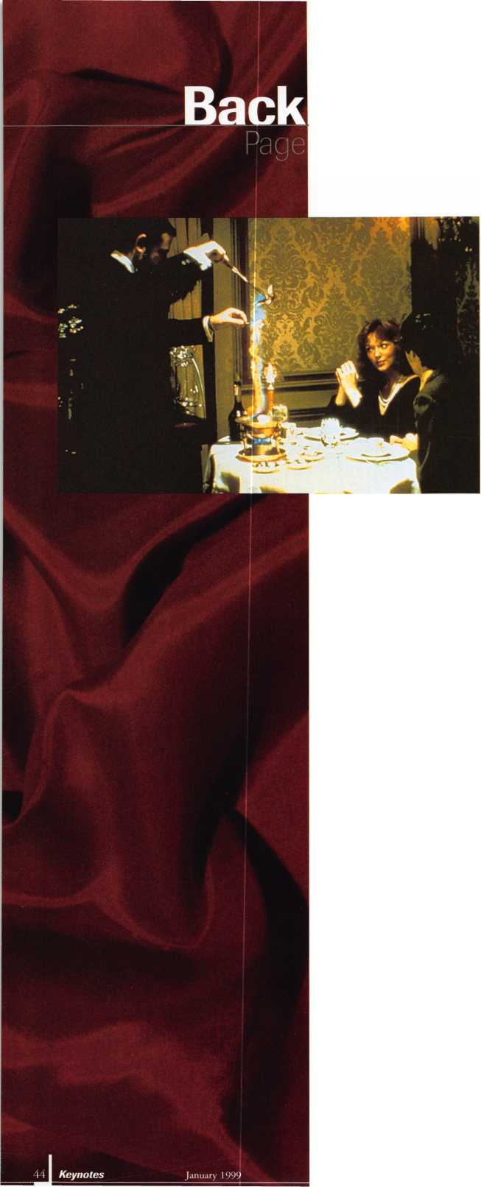

JULY 25-31
Plan now to be in the coolest place of all next summer.
Dive into a class, make a splash at a seminar and wave to your friends as you drift through the nation’s largest exposition of locksmith related manufacturers.
Refresh your spirit with a visit to Fountain Square, a ride on a riverboat, or by enjoying the breathtaking river view from Mt. Adams.
ALOA ’99 will be the coolest yet!
Call for details: 800.532.2562, or visit our website: www.aloa.org.

And you also don't have to be a car dealer in order to duplicate | transponder
All you have to be is a professional locksmith and have a Jet ETD-1 to duplicate transponder
Jet's easy to use decoder quickly and accurately duplicates the most popular transponder keys, including CADILLAC CATERA, HONDA, ACURA, MAZDA and AUDI/VOLKSWAGEN.
Included with your purchase are 5 each of the above keys ( a value of S 295.00)
JET HARDWARE MANUFACTURING CORP
800 Hinsdale Street, Brooklyn, NY 11207
k$f
[ | H ir _{v} il
1 V’ ^{K} j
> T iM t
1 [\ j | [i]¹
n [>i iT-i | 1T7T
